As we come and worship, we remember the wurundjeri people, the original custodians of this land

FIRST READING Acts 3:13-15, 17-19
You killed the prince of life; God, however, raised him from the dead.

RESPONSORIAL PSALM SALMO RESPONSORIALE
Lord, let your face shine on us. | Risplenda su di noi, Signore, la luce del tuo volto..
SECOND READING John 2:1-5
Jesus Christ is the sacrifice that takes away our sins and those of the whole world.
.
GOSPEL ACCLAMATION CANTO AL VANGELO
Alleluia, alleluia!  Lord Jesus, make your word plain to us: make our hearts burn with love when you speak.  Alleluia, alleluia! | Alleluia, alleluia  Signore Gesu’, facci comprendere le Scritture; arde il nostro cuore mentre ci parli. Alleluia!
GOSPEL Luke 24:35-48
It is written that the Christ would suffer and on the third day rise from the dead.

THANKS TO THOSE WHO GAVE LAST WEEK
^{st} Collection - Thanksgiving Offering…………………………..$477.00
- Loose Money…………………………………….$393.00
2nd Collection - Presbytery………………………………………..$232.00

PLEASE NOTE THAT THOSE WHO ARE ROSTERED ON TO READ OR GIVE COMMUNION AT MASS ARE KINDLY ASKED, IF POSSIBLE, TO ARRIVE 10 MINUTES BEFORE MASS STARTS

LECTORS - THIS WEEK 14/04/2024 SPECIAL MINISTERS
5.30pm (SAT) – B Nadenbousch N Ziino & D Nguyen
9.00am (SUN) – C Agostinelli & F Multari D Biasibetti, G Calvi & P Leggiero
10.30am (SUN) – N Sua T Nguyen & M Mizzi
LECTORS – NEXT WEEK 21/04/2024 SPECIAL MINISTERS
5.30pm- T Nguyen B Nadenbousch & E Saliba
9.00am- R DiGuglielmo & R Pino L Cavedon, A Sonza & N Mercuri
10.30am- B Clark-Loh D Nguyen & J Iaria

YOUR PRAYERS ARE REQUESTED FOR THE FOLLOWING RECENTLY DECEASED
Angelina SCAPIN (d. Rec. Italay - sister of Maria Sonza),

ANNIVERSARIES & SPECIAL MEMORIES
Francesco PERRI, Angelina & Vincenzo MISIANO, Leonardo VICARIO, Antonio ANASTASIO

ST JOSEPH THE WORKER
_______________________________________NORTH RESERVOIR _________________________________________

79 Wilson Boulevard, North Reservoir 3073

Parish House/Office Tel: 9460 3013 Fax: 9460 8832
Email: reservoirnorth@cam.org.au
www.stjosephtheworker.org.au
School Tel: 9469 7800 Fax: 9462 2949

SUNDAY MASS TIMES: Fr Emmanuel Bonello–Parish Priest WEEKDAY MASS TIMES:

Mb: 0431 643 674

Sat 5.30pm - English Mrs Maria Barnes – School Principal
Sun. 9.00am - Italian Mrs Liz Pistoni – Parish Secretary Tue. 10.00am Italian

Sun. 10.30am – English Wed. 9.10am - English

Thur. 9.10am - English

Maltese Mass Fri. 9.10am - English Sat. 8.30am - English
1st Saturday of the Month 5.30pm Sat. 8.30am-English
Baptisms – Sunday 12.00pm Reconciliation:
Marriages – by Appointment (Individual Confessions)
Sat. 5.00pm or by Appointment

3rd Sunday of Easter Year B 14 April, 2024
CALLED TO BE PROPHETIC WITNESSES

To his Nazi captors, Polish priest and Conventual Franciscan friar Maximilian Kolbe was prisoner number 16670. But to Franciszek Gajowniczczek, his fellow inmate in Auschwitz, Maximilian was much more and his sacrifice would change his life forever.
In late July 1941, a prisoner escape in Auschwitz prompted the deputy camp commander to order the deaths of 10 men to deter future escape attempts. When Maximilian heard Franciszek, who was one of the ten selected, cry out for his wife and children, he volunteered to take his place. Franciszek was reunited with his wife after the war and lived to be 93. He said that, as long as he lived, he would tell everyone about Maximilian’s courageous act of love.
Jesus’s dying and rising again, like Maximilian’s act of sacrifice and love, was not only a moving act of humanity; it was also a prophetic witness of God’s redemptive love.
The gospel reading today describes a vivid post-Resurrection appearance of Jesus. The disciples met Jesus on the road but only recognised him in the breaking of the bread. Then, quite dramatically, they see him standing in their midst and they were both terrified and overjoyed to see him again. He invites them to touch his hands and feet. He eats a piece of fish which they give him.
At Easter, we enter into the mystery of the death and resurrection of Jesus. God, in his love for us, yearns to draw us into his presence for all eternity. It is a profound paradox that his gift of eternal life and love entailed the ultimate sacrifice of an excruciating death on the cross.
For each of us, taking up our cross also means we are utterly vulnerable to pain, suffering and death. Nevertheless, with the grace of One who has also walked this path, we find strength to do the same. St John of the Cross likened suffering to being like a log in the fire. We are consumed by his love and are forever transformed by the experience. Our suffering becomes transformative if we yield ourselves entirely to God. Yet, our faith is not only a source of grace in own individual suffering and death. It is a prophetic witness for all time. Jesus reminds his disciples that everything that was written about him in the Law of Moses, the Prophets and the Psalms has now been fulfilled, and that repentance and forgiveness of sins will be preached to all nations, beginning with Jerusalem.
We are called to rise with Jesus to a new life. In communion with our faith companions and all the saints from ages past, present and future, we are also called to be prophetic witnesses to his redemptive love. Clothed in our baptismal garments, anointed by holy oil, and redeemed by blood, let us proclaim this Easter promise to everyone. He is risen indeed.
Sophie Clements

POPE’S MONTHLY PRAYER INTENTION FOR APRIL 2024
FOR THE ROLE OF WOMEN
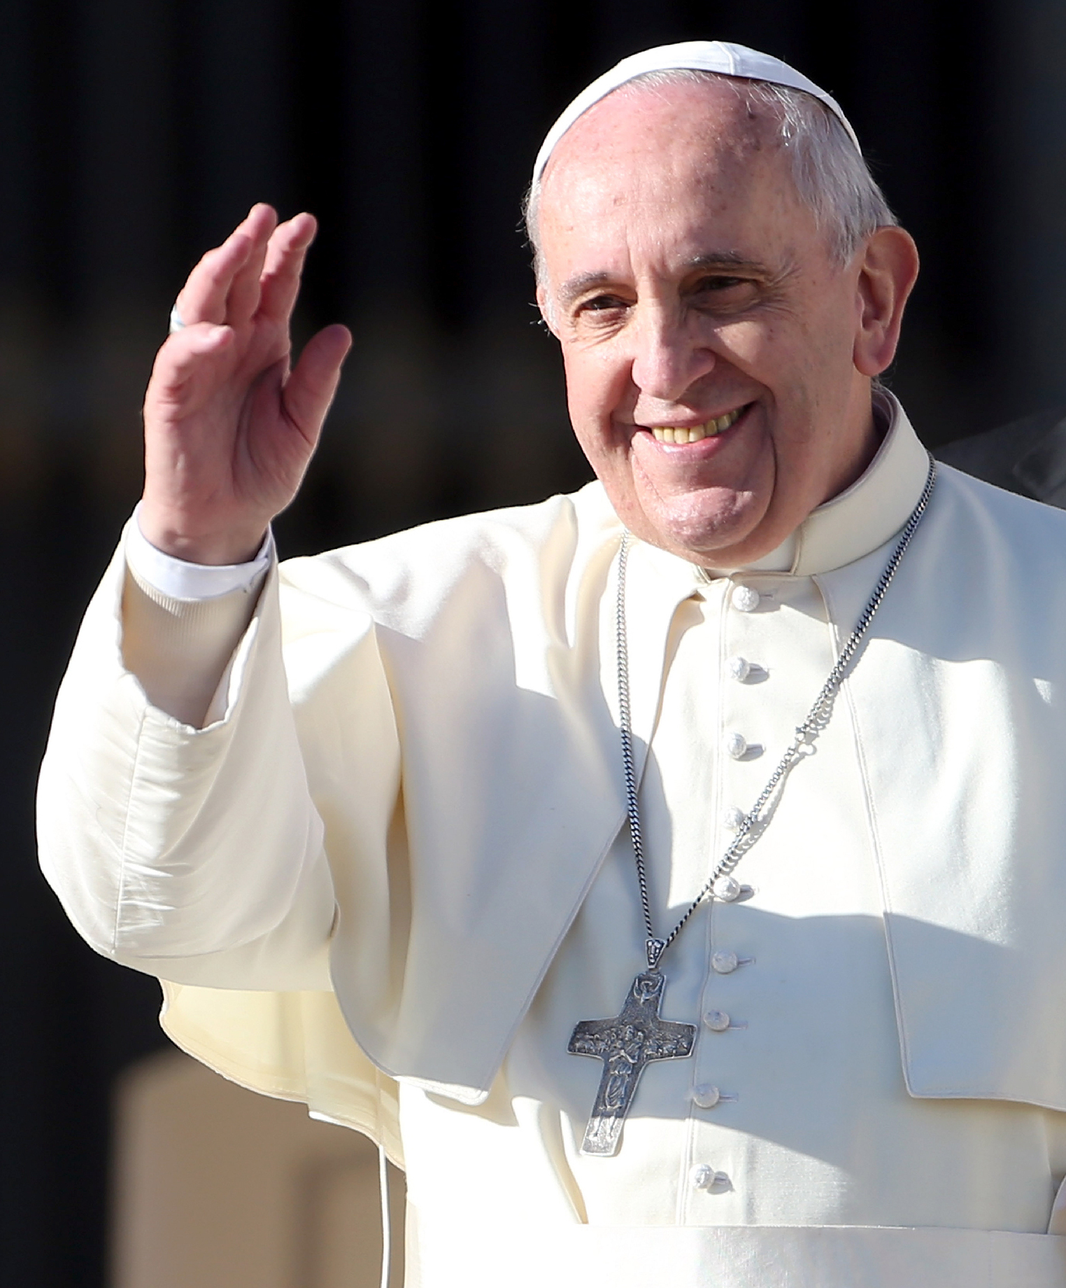
With the Prayer intention for this month of April, Pope Francis insists on today’s society to take steps and respect the role of women in the world. The Pope asks everyone to respect women who unfortunately are often victims of violence and abuse in many parts of the world, even in countries claiming to be more advanced. “And if we don’t [respect women],” the Pope adds, “our society will not progress.” Fr. Frédéric Fornos S.J., International Director of the Pope’s Worldwide Prayer Network, reflected on this month’s intention, recalling that “from the beginning, Jesus welcomed women as His disciples. This was a novelty in the society of that time.” Fr. Fornos added that the Gospels tell us that Jesus’ Mother Mary held a prominent place among the Apostles and in the early community and that Jesus entrusted the mission of announcing His Resurrection to a woman, Mary Magdalene. Fr. Fornos spoke of the great contribution to the Church by many women such as: St Teresa of Avila, St Catherine of Siena and Saint Thérèse of Lisieux, all of whom are Doctors of the Church, along with countless other female saints.
PRAYER “Let us pray that the dignity and worth of women be recognised in every culture and for an end to the discrimination they face in various parts of the world.”

BAPTISMS
Congratulations to Franki Paino child of Antonio and Renee, Ataahua Carlson child of Ruka and Monique, Ella & Lily Pastou children of Bill and Erin who will be baptised this weekend. We welcome them into our parish community and assure the families of our prayerful best wishes on this happy occasion.

A REMINDER - PLEASE NOTE!!
Memorial names for the weekend bulletin are to be handed into the office no later than WEDNESDAY.

Nomi Memoriale per il Bulletino Domenicale devono essere portati in ufficio non piu’ tardi del MERCOLEDI.

THE YEAR OF PRAYER 2024
In the last weekend’s gospel from St. John and this weekend’s gospel from St Luke, we read about Jesus the Risen Lord who came and stood among his disciples greeting them with the words: Peace Be, With You. In preparation for the Jubilee Year 2025, as we honour this Year 2024 as the Year of Prayer let us pray and reflect on our experience of the peace that Jesus
Christ gives us, and offer the peace of Christ to others.
The peace of Christ seeks healing for the hurting.
The peace of Christ confronts the powerful.
The peace of Christ calms the troubled. The peace of Christ builds community.
The peace of Christ will not stand for injustice. The peace of Christ quiets our spirits.
The peace of Christ goes beyond time. We will take the peace of Christ with us as we go out into the world. Risen Lord help us accepting your Peace for us that we may have: Peace in our heart, Peace in our families, Peace in our communities, Peace in our Church and Peace in the World.

MERCY HEALTH CARE FIRST

At Mercy Place Keon Park, caring for you is our top priority.
Our qualified and compassionate aged care teams tailor care according to your personal interests and needs, providing you with comfort and assurance. Our goal is simple: to enable you to have the best day possible, each and every day. Call us now on 1300 372 616 to book a tour. We look forward to welcoming you into your new home.
Mercy Place Keon Park, 15 Tunaley Parade, Keon Park, Vic 3073 | mercyhealth.com.au


MISSION: TRASFORM LIVES:-Theirs and Yours. Communities in Africa, Asia, Australia and the Pacific are looking for qualified and experienced Australians from ALL sectors to share their skills with those who have had little opportunity for formal training. You too will learn and grow within a most welcoming community. Join our two-week tour to Timor-Leste on 06/05/2024 to see Palms program participants our local partner communities in action together.
Contact: 02 9560 5333 palms@palms

HAND SANITISING FOR SAFETY PRACTICES
As in many other places for people to sanitise their hands, please know that “Hand Sanitiser Bottles” are available in the Church, at the entrance and side doors and at the seats on the way to receiving communion. When you go to receive communion, please sanitise your hands and receive communion Only on the Hand. Please feel free, if you wish to wear a mask. THANKS.

MASS ON C31 (d.44)
For those unable to attend church due to illness or other reasons there is an opportunity to follow the 11.00am Sunday Mass from St. Patrick’s Cathedral, Melbourne, which is broadcast live on the TV station C31 Melbourne, which is channel 44 on digital TV.

The Parish of St Joseph the Worker, North Reservoir and the Diocese of Melbourne are committed to the care, wellbeing and protection of children, young people and vulnerable people in our community.

