As we come and worship, we remember the wurundjeri people, the original custodians of this land

FIRST READING Acts 2:14:36-41
God has made Jesus both Lord and Christ.

RESPONSORIAL PSALM SALMO RESPONSORIALE
The Lord is my shepherd; there is nothing I shall want. | Il Signore e’ il mio pastore: non manco di nulla.
SECOND READING Peter 2:20-25
You had gone astray but now you have come back in the shepherd and guardian of your souls.

GOSPEL ACCLAMATION CANTO AL VANGELO
Alleluia, alleluia  I am the good shepherd, says the Lord; I know my sheep, and mine know me.  Alleluia! | Alleluia, alleluia!  Io sono il buon pastore, dice il Signore, conosco le mie pecore e le mie pecore conoscono me. Alleluia!
GOSPEL John 10:1-10
I am the gate of the sheepfold.

THANKS TO THOSE WHO GAVE LAST WEEK
1st Collection - Thanksgiving Offering…………………………..$ 672.00
- Loose Money…………………………………….$445.00
2nd Collection - Presbytery………………………………………..$455.00

LECTORS - THIS WEEK 11/05/2014 SPECIAL MINISTERS
6.00pm (SAT) – E Saliba & N Ziino S Dakin & M Mizzi
9.00am (SUN) – L Catena & R Mercuri L Calafiore, T Mirigliano & P Leggiero
10.30am (SUN) – J & J Kearney J Iaria, L De Marco & T Nguyen

LECTORS – NEXT WEEK 18/05/2014 SPECIAL MINISTERS
6.00pm (SAT) -E Krygger & Sr T Fitzsimmons J Pullicino & N Ziino
9.00am (SUN) – M Crupi & G Tempone A Sonza, G Barbaro & M Piscioneri
10.30am (SUN) –L Conte & C Antonio R Iuele, P Nguyen, S Rottura

MONEY COUNTERS 12/05/2014 J & J Kearney, E & K Bartlett, C McMahon & S Dakin
19/05/2014 A Sinopoli, F Nardozza, I Manini & R Comito
YOUR PRAYERS ARE REQUESTED FOR THE FOLLOWING
RECENTLY DECEASED
Melita MIZZI, Lorenzo NARDELLA, Francesco MIRAGLIA, Fr Rom MURPHY

ANNIVERSARIES
Fioralba VARRASSO, Pasqualina & Domenic ZURZOLO, Domenica, Loreto, Carmela & Antonio TARQUINIO,
Rosa, Angelo & Anna RAULLI, Lucia & Teresa LEONELLO, Giovanna ROMEO, Francesca VENTRA
Grazia CANIZARO, Mario GUIDOLIN, Attilio e Rosina LAGO, Fidalma CIPOLLA, Anna OCCHIUZZI,
Antonina & Giuseppe CATALANO, Domenica & Domenico VARRENTI, Angelina & Giuseppe TODARO,
Costanza CAPOMOLLA, Maria, Olimpia, Antonino , Domenico & Famiglia CARNOVALE
Domenica MOSCA, Pasqualina & Michele NICOLAZZO, Giuseppe SUTERA, Girolamo & Rosa SUTERA,
Giuseppe PINISI, Concetta GAROFOLO, Concetta ROMANO, Adelina LAGANA, Emiglia LAGANA,
Gina DI DONATO, Domenico & Maria-Rosa RUGGIERO, Maria-Giulia & Matteo RICCIO,
Giuseppe BONACCI, Teresa & Francesco BUTERA, Rosa & Saverio NICOLAZZO,
Giuditta PICCONE, Carmela DI GUGLIELMO, Maria-Rosa SALZONE, Assunta SPARANO, Salvatore ROSANO
Cecilia NATALE, Pasqualina SPARANO, Lucia LEONELLO, Antonio PISTONE Anniversaries Cont......
ST JOSEPH THE WORKER
_______________________________________NORTH RESERVOIR _________________________________________

79 Wilson Boulevard, North Reservoir 3073

Parish House/Office Tel: 9460 3013 Fax: 9460 8832 Mb: 0431 643 674
Email: Parish@stjosephtheworker.org.au
www.stjosephtheworker.org.au
School Tel: 9469 7800 Fax: 9462 2949

SUNDAY MASS TIMES: Fr Emmanuel Bonello–Parish Priest WEEKDAY MASS TIMES:

Sat 6.00pm - English Sr Estelita Manabo-Pastoral Associate Mon. 9.10am Comm. Service
Sun. 9.00am - Italian Mr Peter Chowne -School Principal Tue. 10.00am Italian

Sun. 10.30am – English Mrs Liz Pistoni – Parish Secretary Wed. 9.10am - English

Thur. 9.10am - English

Maltese Mass Fri. 9.10am - English Sat. 8.30am - English
1st Saturday of the Month 6.00pm Sat. 8.30am - English Sat. 8.30am-English
Baptisms – Sunday 12.00pm Reconciliation: Sat. 10.30am
Marriages - By Appointment

4th Sunday of Easter, Year A 11 May, 2014
The Easter Way Before Us
When I was 18 years old I went on a road trip across the United States. My family still likes to tell the story about my first phone call home after a couple of weeks on the road. I was in Montana at the time and my uncle was interested to know where I was headed. I told him I didn’t know. He asked how I’d know if I was lost. I replied: “You can’t be lost if you don’t have a destination.” The thing about being 18 and on a road trip is that you don’t need a destination. It can be enough to know that all the destinations that are ready-made and handed to you aren’t for you after all. It can be enough to wonder, and hope for something true and worthwhile along the way.
Eventually the world catches up with most of us. Our attention turns to destinations and preoccupations that at once give aim and direction to our lives and threaten to block out the scenery at the same time. It’s all too easy to miss out on the wonder and beauty of the world when our vision narrowly focuses on the limited destinations nearest to us: earning the next promotion, buying a new home, getting the children into the best school, maintaining a place within a group of friends. The maps in our lives can take over everything else.
The Easter season invites us into a new vision of the world. In today’s Gospel, Jesus uses the images of “shepherd” and “gate” to talk about how in his mission and message he offers the way to fulfillment and true pasturage. His images communicate both the intimacy of his closeness to us and his promise of our total wellbeing. Jesus’ way of forgiveness and love of enemies marks the risky path of a life that avoids careful mopping, because this life asks us to enter into relationships without seeking control. It asks us for genuine friendship. Jesus loved in this way, and now our loving in Christ leads to the fullness of life for us.
No doubt we can yet tangled up with thieves and bandits that lead us away from the gate. Sometimes the destinations and preoccupations of our ordinary lives do precisely that: they close down our hearts and minds to the risk of something new – to a deeper relationship with our spouse, a more caring and discerning presence with our children, a forgiveness for our neighbour, a genuine friendship with our co-workers, a gratitude for life. Easter reminds us that true life does not represent a destination on a map. Our fulfillment and peace as persons and communities is not manufactured by our own efforts. The gate to true life calls us in the voice of the Shepherd, but points us to a risky way that confounds our ordinary logic. If we surrender the ready-made destinations that are handed to us, still we are neither lost nor aimless. In Jesus, we know the experience of being found, and we can see with Easter eyes the way of love in front of us.

A PRAYER FOR MOTHERS

Good and gentle God, we pray in gratitude for our mothers and for all the women
who have joined with you in the wonder of bringing forth new life.
Give them the strength to live and to be loved in return.
Give them the faithful support of family and friends
as they care for the physical and spiritual growth of their children.
Give them joy and delight in their children
to sustain them through the trials of motherhood most all,
give them the wisdom to turn to you for help when they need it most.

Amen.

Good Shepherd Sunday
11 May 2014

In today’s Gospel, the Evangelist records that unlike the thief who enters the sheepfold by another way, the Good Shepherd enters by the door. The sheep hear his voice, he calls them by name and leads them out. Will you hear the Lord’s voice when he calls you? Will you choose the vocation that He has made you for? He has chosen YOU for some work. If you do not do it, it will not get done!

Prayer for Vocations for Families

A Vocation View: This is the World Day of Prayer for Vocations. “The harvest is great but the labourers are few. Pray to the Lord of the harvest to send more labourers into the Harvest.”

We thank you, Lord Jesus, that in becoming man, you chose to belong to a human family. Teach families the virtues which filled with light the family home of Nazareth. May families always be united, as you and the Father are one, and may they be living witnesses to love, justice and solidarity; make them schools of respect, forgiveness and mutual help, so that the world may believe. Help them to be sources of vocations to the priesthood and the consecrated life, and all forms of firm Christian commitment. We ask this through Christ, our Lord. Amen.

(From Pope John Paul II’s encyclical letter Ecclesia de Eucharistia)

BAPTISM
Congratulations to Billie Cardamone child of Frank and Hanna, who will be baptised this weekend. We welcome her into our parish community and assure the family of our prayerful best wishes on this happy occasion.

BAPTISIM PREPARATION
The Baptism Preparation Meeting will be held on Monday 19 May at 7.30pm in the Church.

ITALIAN LADIES
Martedi’ 13 Maggio la Santa Messa delle ore 10.00am sara’ offerta per tutte le mamme, nonne, suocere defunte, portate una loro foto che sara’ posto intorno all’altare. Vi aspettiamo numerose.

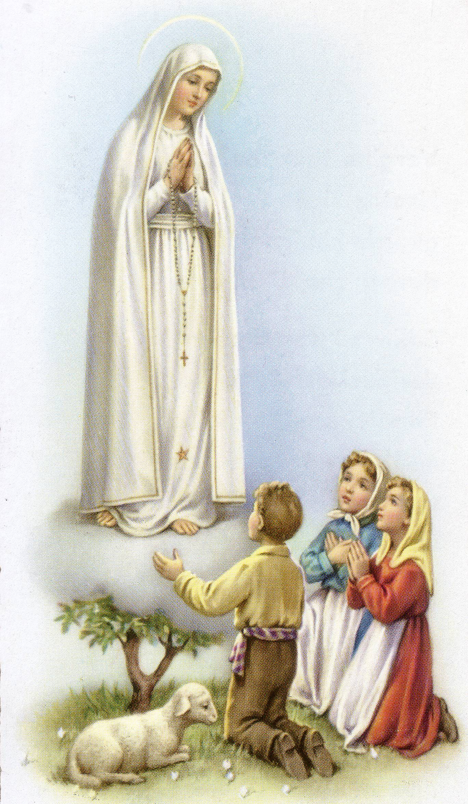
SOLENNE CELEBRAZIONE
DI NOSTRA SIGNORA DI FATIMA
DOMENICA 18 MAGGIO 2014
Nella chiesa di San Giuseppe Lavoratore
79 Wilson Blvd North Reservoir

3.00pm - Santa Messa cantata,
Celebrata da Padre Emanuele Bonello PP & Fr Joseph Yu PE

Segue processione con la statua e recita del Santo Rosario sui piazzali della chiesa. Fiaccolata con Inni e Preghiere. Ritorno in chiesa per la Benedizione Eucaristica.
La celebrazione sara’ accompagnata dal musicista Raffaele Rossi.

Segue un rinfresco!
Per informazione: Renato – 9460 4597 Gina – 9462 1641 Paola – 9460 7990

MEMORIAL MASSES
Tuesday 13 May – 7.00pm – Pasqualina Zurzolo (1mth)
- Domenic Zurzolo (anniversary)
Wednesday 14 May – 7.00pm – Francesco Miraglia (d.rec. Italy)

GIVE HOPE BY GIVING GENEROUSLY TO CHAPLAINCY SUNDAY APPEAL 2014
SUNDAY 18 MAY
Next weekend is Chaplaincy Sunday in the Archdiocese of Melbourne. The Melbourne Archbishop’s Charitable Fund will be conducting a special collection in all parishes for the purpose of supporting the vital work of our Catholic chaplains.
You are invited and encouraged to take home the envelopes in the seats this weekend and bring back next week with your considered donation.
The presence of Catholic Chaplains provides hope to those suffering from loneliness physical illness, mental health challenges and HIV/AIDS. As well as those facing youth detention, a prison sentence or long bouts of time at sea, away from Church support, family and friends.
To find out more please view the Chaplaincy Sunday video clip or donate online at www.cam.org.au/chaplaincy

MAGNIFICAT WITH STEVE ANGRISANO FRIDAY 23 MAY, 7:30PM – 9:30PM
Celebrate the month of Mary with young people from across Melbourne in a joyful night of song and prayer. Featuring international musician Steve Angrisano and a host of talented local artists. Bring your youth group and invite your friends!
Where: Sacred Heart Church, Cnr Rathdowne & Pelham Streets Carlton
Cost: $5 entry. Bookings via www.trybooking.com/83308 Book early to avoid disappointment.
Contact: 9287 5565 or aoy@cam.org.au

Anniversaries Cont….
Carmela PUGLIESE, Caterina FERRARO, Rosaria CINCOTTA, Donata QUINTILI, Linda FELICIANI,
Rocca-Maria DEL ZOTTI, Stella GIAMMARIA, Maria & Raffaele MACCARONE,
Francesca BONGIOVANNI, Vita CICITTA, Luigia VALMORBIDA, Nella CAVEDON,
Amalia MULTARI, Maria COSTANZO, Carmela PINO, Angela ZAIA

