As we come and worship, we remember the wurundjeri people, the original custodians of this land

FIRST READING Acts 6:1-7
They elected seven men filled with the Spirit and wisdom.

RESPONSORIAL PSALM SALMO RESPONSORIALE
Lord, let your mercy be on us, as we place our trust in you. | Il tuo amore, Signore, sia su di noi: in te speriamo.
SECOND READING Peter 2:4-9
But you are a chosen race, a royal priesthood.

GOSPEL ACCLAMATION CANTO AL VANGELO
Alleluia, alleluia  I am the way, the truth, and the life, says the Lord; no one comes to the Father, except through me.  Alleluia! | Alleluia, alleluia!  Io sono la via, la verita’, la vita, dice il Signore: nessuno viene al Padre se non per mezzo di me. Alleluia!
GOSPEL John 14:1-12
I am the way, the truth and the life.

THANKS TO THOSE WHO GAVE LAST WEEK
1st Collection - Thanksgiving Offering…………………………..$ 1005.00
- Loose Money…………………………………….$350.00
2nd Collection - Presbytery………………………………………..$430.00

LECTORS - THIS WEEK 18/05/2014 SPECIAL MINISTERS
6.00pm (SAT) – E Krygger & Sr T Fitzsimmons J Pullicino & N Ziino
9.00am (SUN) – M Crupi & G Tempone A Sonza, G Barbaro & M Piscioneri
10.30am (SUN) – L Conte & C Antonio R Iuele, P Nguyen, S Rottura

LECTORS – NEXT WEEK 25/05/2014 SPECIAL MINISTERS
6.00pm (SAT) -B Nadenbousch & D Pullicino M Mizzi & E Krygger
9.00am (SUN) – G Calvi & R Fato L Catena, M Crupi & A DiRico
10.30am (SUN) –J Akinido & G Canavan J Frangiosa & J & J Kearney

MONEY COUNTERS 19/05/2014 A Sinopoli, F Nardozza, I Manini & R Comito
26/05/2014 E Claridge, F Carabott & G Canavan
YOUR PRAYERS ARE REQUESTED FOR THE FOLLOWING
RECENTLY DECEASED
Elena RAGO, Albina GIACCA, Carlu CAMILLERI

ANNIVERSARIES
Giovanni VALENTINIS, Michele CIAVARELLA, Bartolo TARANTO, Carlo MARIANI, Sebastiano BUCCHIERI
Virginia CENTOFANTI, Rose GALEA, Joseph PHAM, Anne HAM TIEU, Angela PUCCIO,
Maria-Teresa CIMINO, Pasquale & Carmela BONACCI, Orsola & Anita PANE, Margherita GARRO,
Giuseppa TIRALONGO, Giuseppa ITALIA, Santina LIBRIO, Maria SACUZZO, Paola & Maria MAZARELLA,
Francesco ITALIA, Giuseppe, Natale & Maria FATO, Concetta PAPALIA, Kathy PAPALIA, Maria BELLE
Antonio PISCIONERI, Mary PIRRITANO, Rosa PISCIONERI, Saverio & Attilio COLOSIMO,
Maria-Grazia MURDICA, Angelo, Rosa & Antonio CRITELLI, Elvira & Nicola LOFARO,
Teresa & Giuseppe BONACCI, Paolina QUATTROCELLI, Mariarosa DI RICO, Antonio GOBAIRA

ST JOSEPH THE WORKER
_______________________________________NORTH RESERVOIR _________________________________________

79 Wilson Boulevard, North Reservoir 3073

Parish House/Office Tel: 9460 3013 Fax: 9460 8832 Mb: 0431 643 674
Email: Parish@stjosephtheworker.org.au
www.stjosephtheworker.org.au
School Tel: 9469 7800 Fax: 9462 2949

SUNDAY MASS TIMES: Fr Emmanuel Bonello–Parish Priest WEEKDAY MASS TIMES:

Sat 6.00pm - English Sr Estelita Manabo-Pastoral Associate Mon. 9.10am Comm. Service
Sun. 9.00am - Italian Mr Peter Chowne -School Principal Tue. 10.00am Italian

Sun. 10.30am – English Mrs Liz Pistoni – Parish Secretary Wed. 9.10am - English

Thur. 9.10am - English

Maltese Mass Fri. 9.10am - English Sat. 8.30am - English
1st Saturday of the Month 6.00pm Sat. 8.30am - English Sat. 8.30am-English
Baptisms – Sunday 12.00pm Reconciliation: Sat. 10.30am
Marriages - By Appointment

5th Sunday of Easter, Year A 18 May, 2014
I am the Way
During the period between the resurrection of Jesus and the coming of the Holy Spirit at Pentecost we are invited to be one in spirit with the disciples. We can imagine that their minds often returned to think about the things Jesus had taught them and particularly to that momentous conversation at the Last Supper. It was then that Jesus had been at pains to prepare them for the future. He would return to his Father, but would not leave them orphans. He was going to prepare a place for them and for all of us – what a consolation it is to know that there are many rooms in his Father’s house: room for all of us!
Nevertheless, for all Jesus’ efforts to reassure the disciples, they clearly remained confused and uncertain. Thomas confessed that he did not know where Jesus was going and it would be interesting to know how much he understood of Jesus’ reply to his request for directions: “I am the way.” By the time John wrote his Gospel, many years had elapsed and there had been time to think through and piece together the story. We are the beneficiaries of that prayer and reflection.
By the time the gospels and the New Testament letters were being written, the disciples and their early Christian communities had grasped the fact that the key to a successful journey through life was to be united to Jesus and to imitate him, to live as he had lived. But we should not imagine that this discovery had left them comfortably sure about how to resolve every problem that beset them. We see how there were real tensions about how to deal with the practical problem of ensuring that everyone was being properly fed; and it was this that led to the ordination of the first deacons.
Meanwhile Peter recognises that following the way demands faith in the person of Jesus, whom he describes as a living stone, the precious cornerstone around which the whole Church is being built. If we do not put our faith in this word of God, then Jesus becomes the stone in the way, the stone that we will trip over. Jesus’ assurance was that his returning to the Father would enable us to live as he did, to perform the works he had performed. In fact he promises that we will perform even greater works: therein lays the challenge for us.
Do we believe in this way? Do we believe that Jesus has set us apart to be “a royal priesthood and a consecrated nation”? Do we believe that he has sent us his Spirit so that we too can solve the problems that beset us?
Lord help us to walk in your way; help us to know your word is truth so that we can live in your wonderful light. Deepen our faith in all your promises so that, when you return, we will be ready to greet you, and be reunited with all who have gone before us.

BAPTISIM PREPARATION
The Baptism Preparation Meeting will be held on Monday 19 May at 7.30pm in the Church.

FIRST EUCHARIST COMMITMENT MASS
Next weekend 6.00pm and 10.30am Masses are the commitment Masses for the children of our parish who are preparing to receive the sacrament of First Eucharist on 22 June. We pray and ask God’s blessings for these children.


CUPPA
There will be a Cuppa in the Narthex after the 10.30am Mass this weekend. Please stop and enjoy the hospitality of the parish and meet some fellow parishioners.

FUNERAL
Funeral for Albina Giacca will be celebrated on Tuesday 20 May at 11.30am.

MEMORIAL MASSES
Monday 19 May – 8.00pm – Michele Ciavarella
Friday 23 May – 7.30pm – Angelo Torchia

GIVE HOPE BY GIVING GENEROUSLY TO CHAPLAINCY SUNDAY 18 MAY
The Melbourne Archbishop’s Charitable Fund will be conducting an Appeal in parishes to support the vital work of Catholic Chaplains in our community this Sunday 18 May.
Parishioners are encouraged to offer prayers and a financial offering to assist chaplains to provide hope to those suffering from loneliness, physical illness, mental health challenges and HIV/AIDS. As well as those facing youth detention, a prison sentence or long bouts of time at sea away from Church support, family and friends.

We ask you to please be generous in your contributions. You will find envelopes in the pews of the church.

To find out more please view the Chaplaincy Sunday video clip at: www.cam.org.au/chaplaincy
Or contact the Development Office: 9926 5731

MAGNIFICAT WITH STEVE ANGRISANO FRIDAY 23 MAY, 7:30PM – 9:30PM
Celebrate the month of Mary with young people from across Melbourne in a joyful night of song and prayer. Featuring international musician Steve Angrisano and a host of talented local artists. Bring your youth group and invite your friends!
Where: Sacred Heart Church, Cnr Rathdowne & Pelham Streets Carlton
Cost: $5 entry. Bookings via www.trybooking.com/83308 Book early to avoid disappointment.
Contact: 9287 5565 or aoy@cam.org.au

ST MONICA'S COLLEGE, EPPING GOLDEN JUBILEE SUNDAY 25 MAY, 2PM.
Join us as we celebrate our golden jubilee with a Mass at St Francis of Assisi Parish Church, Mill Park. College alumni, former staff members and others who have been associated with St Monica's College since 1964 are invited to join current staff and students for this Jubilee Mass.
Light refreshments will be served in the parish hall at the conclusion of Mass.
Where: St Francis of Assisi Parish Church, 290 Childs Road, Mill Park.

SOLO CATHOLICS DINING & DANCING FRIDAY 23 MAY, 7PM
Single Catholics of all ages are welcome to join us for an enjoyable night, including dinner and dancing.
Where: Beaumaris RSL, 489 Balcombe Road Beaumaris
Contact: John 0411 483 314

PARISH GATHERING
ON POPE FRANCIS’ GOSPEL MESSAGE

Parishioners are invited to attend an evening gathering
to be held on Thursday 5th June 2014
at 7.30pm in our Parish School Hall.
(There will be a cuppa starting at 7.00pm)
The Guest Speaker will be: Rev Dr Elio Capra SDB.
Fr Elio will give us a talk and lead us in a reflection on the topic:

‘POPE FRANCIS’ GOSPEL MESSAGE’
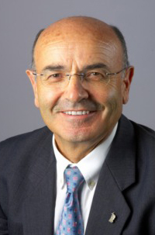
In the light of his apostolic letter of exhortation on the proclamation of the Gospel in today’s World: The Joy of the Gospel.’
This will lead us to explore and follow Pope Francis’ words and example who at the beginning of his letter said: “In this Exhortation I wish to encourage the Christian Faithful to embark upon a new chapter of evangelisation marked by this Joy: The Joy of the Gospel”
Please keep the 5th of June free and join us in this our special gathering.

ALL ARE WELCOME.

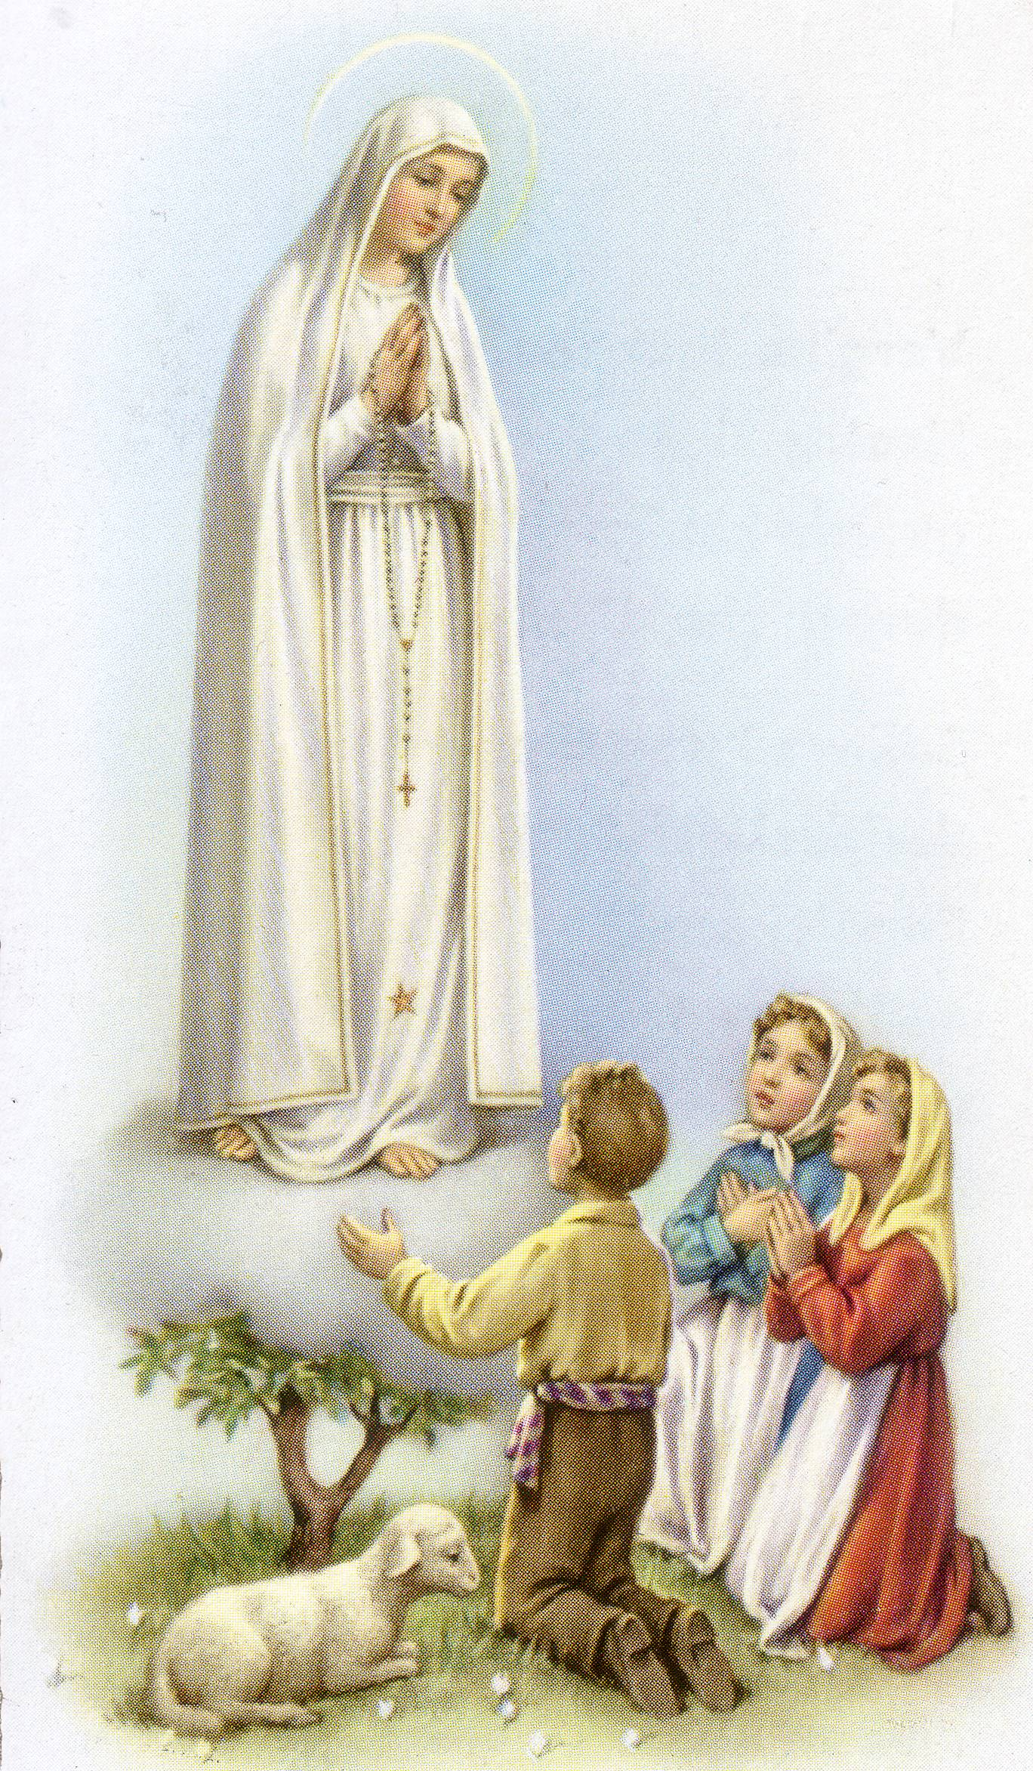
SOLENNE CELEBRAZIONE
DI NOSTRA SIGNORA DI FATIMA
DOMENICA 18 MAGGIO 2014
Nella chiesa di San Giuseppe Lavoratore
79 Wilson Blvd North Reservoir

3.00pm - Santa Messa cantata,
Celebrata da Padre Emanuele Bonello PP & Fr Joseph Yu PE

Segue processione con la statua e recita del Santo Rosario sui piazzali della chiesa. Fiaccolata con Inni e Preghiere. Ritorno in chiesa per la Benedizione Eucaristica.
La celebrazione sara’ accompagnata dal musicista Raffaele Rossi.

Segue un rinfresco!
Per informazione: Renato – 9460 4597 Gina – 9462 1641 Paola – 9460 7990

