As we come and worship, we remember the wurundjeri people, the original custodians of this land

FIRST READING Genesis 18:20-32
Lord, do not be angry if I speak.

RESPONSORIAL PSALM SALMO RESPONSORIALE
Lord, on the day I called for help, you answered me. | Nel giorno in cui to ho invocato mi hai risposto.
SECOND READING Colossians 2:12-14
He has made you alive with Christ for he has forgiven all our sins.

GOSPEL ACCLAMATION CANTO AL VANGELO
Alleluia, alleluia!  You have received the Spirit which makes us God’s children, and in that Spirit we call God our Father.. Alleluia! | Alleluia, alleluia  Avete ricevuto lo Spirito che rende figli adottivi, per mezzo del quale gridiamo: Abba! Padre!. Alleluia.
GOSPEL Luke 11:1-13
Ask, and it will be given to you.

THANKS TO THOSE WHO GAVE LAST WEEK
^{st} Collection - Thanksgiving Offering…………………………..$427.00
- Loose Money…………………………………….$242.00
2nd Collection - Presbytery………………………………………..$200.00

PLEASE NOTE THAT THOSE WHO ARE ROSTERED ON TO READ OR GIVE COMMUNION AT MASS ARE KINDLY ASKED, IF POSSIBLE, TO ARRIVE 10 MINUTES BEFORE MASS STARTS

LECTORS - THIS WEEK 17/07/2022 SPECIAL MINISTERS
5.30pm (SAT) – E Saliba N Ziino & B Nadenbousch
9.00am (SUN) – G Calvi & C Brunetti D Biasibetti, R Pino & P Leggiero
10.30am (SUN) – L Conte P Nguyen & M Mizzi
LECTORS – NEXT WEEK 24/07/2022 SPECIAL MINISTERS
5.30pm- B Nadenbousch E Saliba & S Dakin
9.00am- C Agostinelli & F Multari A Sonza, L Calafiore & N Mercuri
10.30am- R Covello V De Leo & B Clark-Loh
YOUR PRAYERS ARE REQUESTED FOR THE FOLLOWING RECENTLY DECEASED
Concetta MARTINO, Rosaria RAPA,Domenico TEMPONE, Br. Joe PANTALLERESCO MSSP
Vincenza CORRONE
ANNIVERSARIES & SPECIAL MEMORIES
Silvana & Aldo DI PASQUALE, Nicola PRIVINZANO, Daryl KENNAN, Emilia TARQUINIO,
Giuseppe D’AUGELLO, Domenico MORANO, Maria DE THOMASIS, Rosa & Giuseppe FATO,
Francesco CONTE,Ernie GANINO, Salvatore IOZZI, Bambina & Sante GUGLIELMI,
Elisabetta MEMOS

ST JOSEPH THE WORKER
_______________________________________NORTH RESERVOIR _________________________________________

79 Wilson Boulevard, North Reservoir 3073

Parish House/Office Tel: 9460 3013 Fax: 9460 8832
Email: Parish@stjosephtheworker.org.au
www.stjosephtheworker.org.au
School Tel: 9469 7800 Fax: 9462 2949

SUNDAY MASS TIMES: Fr Emmanuel Bonello–Parish Priest WEEKDAY MASS TIMES:

Mb: 0431 643 674

Sat 5.30pm - English Mrs Maria Barnes – School Principal
Sun. 9.00am - Italian Mrs Liz Pistoni – Parish Secretary Tue. 10.00am Italian

Sun. 10.30am – English Wed. 9.10am - English

Thur. 9.10am - English

Maltese Mass Fri. 9.10am - English Sat. 8.30am - English
1st Saturday of the Month 5.30pm Sat. 8.30am-English
Baptisms – Sunday 12.00pm Reconciliation:
Marriages – by Appointment (Individual Confessions)
Sat. 5.00pm or by Appointment

17th Sunday in Ordinary Time Year C 24 July, 2022
THE PROMISE OF GOD’S GRACE

A disciple says, “Lord, teach us to pray.” In reply, Jesus offers a four-point lesson in prayer.
Firstly, Jesus invites his followers to address God as ‘Father’. This would’ve been revolutionary! Out of respect and awe, they didn’t use God’s name in prayer. Now Jesus teaches that they’re members of God’s family; sisters and brothers who are to call God ‘Father’. In Jewish society, fathers had responsibility to love and care for their wives and children; a very personal relationship. It’s this kind of intimate relationship with God that Jesus invites us all to embrace.
Secondly, being sisters and brothers in God’ family, we’re to have concern for everyone and for the issues that are important to God’s loving and merciful heart. In praying for our own needs, we’re also called to broaden our perspective and see the ‘bigger picture’ by praying that God’s love for humanity will be known everywhere and that all people will love each other and live in peace and harmony.
Thirdly, we’re to be persistent in our prayer. In the first reading, Abraham asks God to spare Sodom – and he was persistent! Jesus tells his followers, “Ask, and it will be given you; search, and you will find; knock, and the door will be opened” (Lk 11:9). Jesus tells them to ask their Heavenly Father who knows all their needs and they will be heard.
He also reminds them that whenever two or three of them agree to ask anything in his name, it will be granted (cf. Mt 18:19). In other words, never shy away from ‘pestering’ or ‘bothering’ God. Finally, God gives what is good for us. Most of us have had the experience of praying for something, but God didn’t answer our prayer. It’s hard to accept or understand that what we’re asking for may not be good for us. Jesus says that a loving Father would never give a stone to anyone who wants bread, or a snake to anyone who wants fish, or a scorpion to anyone who wants food. Jesus doesn’t promise what can’t be delivered and he doesn’t say ‘your wish is granted’. Rather, Jesus challenges us to realise “how much … the Father will give the Holy Spirit to those who ask” (Lk 13). What Jesus promises is grace. He promises the Holy Spirit – to sustain us, uplift us, and help us to endure. The Holy Spirit empowers us to accept God’s plan – even if it’s not our plan – and to get up, go on and face another day. St Alphonsus Liguori, the founder of the Redemptorists and a Doctor of Prayer, says that we don’t pray to change God, but that God might change the one who prays and the community which prays. When we open ourselves to God’s grace and action in this way, we’ll be changed and become instruments of God’s love.

David J Hore CSsR

WORLD DAY FOR GRANDPARENTS AND ELDERLY 24 JULY 2022

"In old age they will still bear fruit" (Psalm 92:1)

In his message Pope Francis said that these words of the Psalmist are glad tidings, a true “gospel” that we can proclaim to all on this second World Day for Grandparents and the Elderly. … Blessed is the house where an older person lives! Blessed is the family that honours the elderly. … Pope Francis refered to a psalm that – urges us to persevere in hope. “Along with old age and white hairs”, said Pope Francis, “God continues to give us the gift of life and to keep us from being overcome by evil. If we trust in God, we will find the strength to praise God still. We will come to see that growing old is more than the natural decline of the body or the inevitable passage of time, but the gift of a long life. Aging is not a condemnation, but a blessing! … Old age is no time to give up and lower the sails, but a season of enduring fruitfulness: a new mission awaits us and bids us look to the future.” Pope Francis encouraged everyone and said: “Let us make sure that no one feels alone on this day. Expecting a visit can transform those days when we think we have nothing to look forward to; from an initial encounter, a new friendship can emerge. Visiting the elderly who live alone is a work of mercy in our time!” Finally, Pope Francis entrusted his message to the Virgin Mary, Our Lady, Mother of Tender Love, and addressing the grandparents and elderly with his blessing and said: “To all of you, and to your loved ones, I send my blessing and the assurance of my closeness and affection. And I ask you, please, not to forget to pray for me!” Let us pray for all grandparents and elderly people, that their wisdom and life experiences be valued and honoured

GIORNATA MONDIALE DEI NONNI E DEGLI ANZIANI 24 Luglio 2022
"Nella vecchiaia daranno ancora frutti" (Sal 92,15)
“Carissima, carissimo! Il versetto del salmo 92 «nella vecchiaia daranno ancora frutti» è una buona notizia, un vero e proprio “vangelo”, che in occasione della seconda Giornata Mondiale dei Nonni e degli Anziani possiamo annunciare al mondo. … Benedetta la casa che custodisce un anziano! Benedetta la famiglia che onora i suoi nonni! … La vecchiaia non è un tempo inutile in cui farci da parte tirando i remi in barca, ma una stagione in cui portare ancora frutti. … Facciamo in modo che nessuno viva questo giorno nella solitudine. Avere qualcuno da attendere può cambiare l’orientamento delle giornate di chi non si aspetta più nulla di buono dall’avvenire; e da un primo incontro può nascere una nuova amicizia. La visita agli anziani soli è un’opera di misericordia del nostro tempo! … A tutti voi e ai vostri cari giunga la mia Benedizione, con l’assicurazione della mia affettuosa vicinanza. E voi, per favore, non dimenticatevi di pregare per me!” (Dal messaggio di Papa Francesco).

FEASTS
Monday 25 July – St James, apostle
Tuesday 26 July- Sts Jaochim & Anne, parents of Blesssed Virgin Mary
Friday 29 July- Sts Martha, Mary & Lazarus

ADORAZIONE EUCARISTICA
Martedi 26 Luglio 2022 Adorazione Eucaristica ore 9.00am. Segue S. Messa ore 10.00am.

MASS ON C31 (d.44)
For those unable to attend church due to illness or other reasons there is an opportunity to follow the 11.00am Sunday Mass from St. Patrick’s Cathedral, Melbourne, which is broadcast live on the TV station C31 Melbourne, which is channel 44 on digital TV.

COVID SAFE PRACTICES
- As we come in Church, we are asked to be aware of some good practice against the transmission of the Corona-virus.
- Please sanitise your hands as you enter the church and on the way before receiving Communion as well as on the way out of the Church. Hand Sanitiser Bottles are available at the entrances of the Church and at a seat as you walk to receive communion. Please receive Communion only on the Hand.
- Masks are not compulsory but recommended. You may wish to wear it or not. Ministers of Communion should wear a mask while distributing communion.
- THANKS to all those who have been and continue to be of great help to keep following well the required measures of Covid-19.

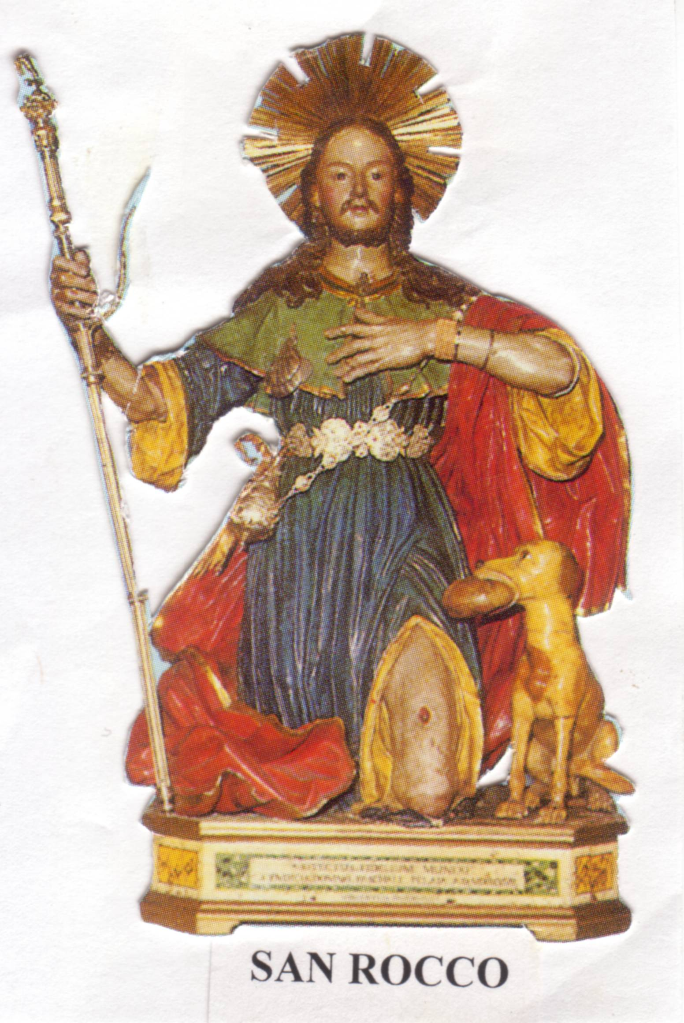
FESTA SAN ROCCO
Celebrazione della Festa di San Rocco
Domenica 21 Agosto nella chiesa di San Giuseppe Lavoratore North Reservoir
Ore 8.30am - Preghiere e Canti
Ore 9.00am - Santa Messa in italiano accompagnata dall’organista e cantante Rev Padre Raffaele Rossi

Per motive del covid non ci sara’ la benedizione e distribuzione del pane di devozione.
Se portate dei panini di casa, li terrete con voi e saranno benedetti dall’altare alla
conclusione della Santa Messa. San Rocco attende tutti devoti per spargere grazie e
benedizioni! Venite numerosi domenica 21 agosto.

CARITAS AUSTRALIA – UKRAINE EMERGENCY APPEAL
The people of Ukraine are living through a crisis that will impact the country for years to come. Caritas Australia has launched an appeal to support Caritas Ukraine and other partners in the region. The appeal will support the provision of clean water, hygiene and food kits to vulnerable families, as well as safe collection centres for families on the move, emergency accommodation and support for distressed children and families.
Online: https://www.caritas.org.au/donate/emergency-appeals/ukraine/ Phone: 1800 024 413

FOR A SYNODAL CHURCH: COMMUNION, PARTICIPATION AND MISSION
PRAYER FOR THE SYNOD: Adsumus Sancte Spiritus

We stand before You, Holy Spirit, as we gather together in Your name. With You alone to guide us, make Yourself at home in our hearts; Teach us the way we must go and how we are to pursue it. We are weak and sinful; do not let us promote disorder. Do not let ignorance lead us down the wrong path nor partiality influence our actions. Let us find in You our unity so that we may journey together to eternal life and not stray from the way of truth and what is right. All this we ask of You, who are at work in every place and time, in the communion of the Father and the Son, forever and ever. Amen.
For general information visit www.synod.va
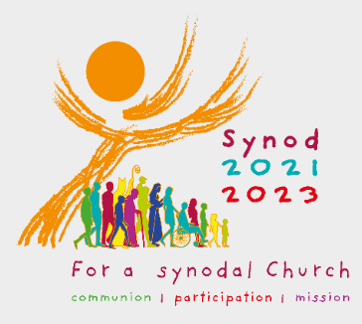

The Parish of St Joseph the Worker, North Reservoir and the Diocese of Melbourne are committed to the care, wellbeing and protection of children, young people and vulnerable people in our community.

