As we come and worship, we remember the wurundjeri people, the original custodians of this land

FIRST READING Deuteronomy 4:1-2, 6-8
You may add nothing to the word which I speak to you – keep the commands of the Lord.

RESPONSORIAL PSALM SALMO RESPONSORIALE
The just will live in the presence of the Lord. | Chi teme il Signore abitera’ nella sua tenda.
SECOND READING St James 1:17-18, 21-22, 27
Be doers of the word.

GOSPEL ACCLAMATION CANTO AL VANGELO
Alleluia, alleluia!  The Father gave us birth by his message of truth, that we might be as the first fruits of his creation. Alleluia! | Alleluia, alleluia.  Per sua volonta’ il Padre ci ha generati per mezzo della parola di verita’, per essere una primizia delle sue creature. Alleluia!
GOSPEL Mark 7:1-8, 14-15, 21-23
You forget the commandments of God to hold on to human tradition.

THANKS TO THOSE WHO GAVE LAST WEEK
1st Collection - Thanksgiving Offering…………………………..$590.00
- Loose Money…………………………………….$289.00
2nd Collection - Presbytery………………………………………..$365.00

PLEASE NOTE THAT THOSE WHO ARE ROSTERED ON TO READ OR GIVE COMMUNION AT MASS ARE KINDLY ASKED, IF POSSIBLE, TO ARRIVE 10 MINUTES BEFORE MASS STARTS
LECTORS - THIS WEEK 02/09/2018 SPECIAL MINISTERS
6.00pm (SAT) – MALTESE MASS (Selected) MALTESE MASS (Selected)
9.00am (SUN) – G Tempone & G Calvi O Strangis, M Crupi, A DiRico & T Forte
10.30am (SUN) – D Comi & R Iuele P & K Nguyen, V De Leo & M Mizzi
LECTORS – NEXT WEEK 09/09/2018 SPECIAL MINISTERS
6.00pm (SAT) E Saliba & Sr T Fitzsimmons N Ziino & T Nguyen
9.00am (SUN) – R Fato & M Crupi M Piscioneri, M Forte, G Tempone & C Alberti
10.30am (SUN) – L Conte & B Clark-Loh S Dakin, J Iaria, D Schembri & S Rottura
MONEY COUNTERS 03/09/2018 S Dakin & L De Marco
10/09/2018 J Kearney, E Bartlett & S Dakin

YOUR PRAYERS ARE REQUESTED FOR THE FOLLOWING RECENTLY DECEASED
Maria RABAR, Ron CORNELIOUS,
ANNIVERSARIES & SPECIAL MEMORIES
Emmanuel MERCIECA, Robbie CIANTAR, Maria CAVALERI, Nicola ALBERTI, Rachele GRECO,
Giuseppe TARANTO, Rosa, Gaetano, Lorenzo & Marina ZAGAMI, Anna SALTALAMACCHIA,
Domenico SOLEA, Giuseppe & Stefano D’AGOSTINO, Salvatore PIACENTE, Ercole GRETO,
Nicola PIACENTE, Maria-Elizabeth CIRACO, Domenic GRETO, Maria GIRONDA & Families
Giuseppe, Gaspare, & Mario CATALANO, Domenico VARRENTI, Nino SCALIA,
Michele & Luciano NICOLAZZO, Ferdinando & Raffaele BRUSCO,Giuseppe TODARO,
John & Luigi PASCUZZI, Michelangelo, Giovanni & Michael BUTERA, Franco ARCIERI,
Janez & Matteo ZELE, Antonio GRAHOR, Luigi CAVEDON, Giovanni VALMORBIDA,
Giacomo CAVEDON, Giuseppe FERRENTINO, Carmine COSTANZO, Domenico PICCONE, Ann. Con..

ST JOSEPH THE WORKER
_______________________________________NORTH RESERVOIR _________________________________________

79 Wilson Boulevard, North Reservoir 3073

Parish House/Office Tel: 9460 3013 Fax: 9460 8832
Email: Parish@stjosephtheworker.org.au
www.stjosephtheworker.org.au
School Tel: 9469 7800 Fax: 9462 2949

SUNDAY MASS TIMES: Fr Emmanuel Bonello–Parish Priest WEEKDAY MASS TIMES:

Mb: 0431 643 674

Sat 6.00pm - English Sr Estelita Manabo-Pastoral Associate Mon. 9.10am Comm. Service
Sun. 9.00am - Italian Mrs Maria Barnes -School Principal Tue. 10.00am Italian

Sun. 10.30am – English Mrs Liz Pistoni – Parish Secretary Wed. 9.10am - English

Thur. 9.10am - English

Maltese Mass Fri. 9.10am - English Sat. 8.30am - English
1st Saturday of the Month 6.00pm Sat. 8.30am - English Sat. 8.30am-English
Baptisms – Sunday 12.00pm Reconciliation: Sat. 10.30am
Marriages - By Appointment

22nd Sunday in Ordinary Time, Year B 2 September, 2018
A matter of justice
Having observed that Jesus’ disciples were not complying with the religious purification laws of the time which required one to wash one’s hands thoroughly before eating, the Pharisees challenged Jesus once again.
Not following those laws meant that the disciples were eating with hands that were deemed to be “unclean” or “impure”. The Pharisees were infuriated Jesus appeared to be unconcerned about this matter of ritual purification.
“You hypocrites,” Jesus replied. “You disregard God’s commandment but cling to human tradition.” The hand-washing law, he implied, is a human tradition, a man-made regulation. Jesus threw the challenge back at them: ritual purity is not a matter of cleaning one’s hands, he insists, but of purity of heart! He explains: “Nothing that enters one from outside can defile that person; but the things that come out from within are what defile.”
By Jesus’ time, the rabbis had identified 613 commands that were prescribed in the Torah (the first five books of the Bible), not just the 10 commandments given to Moses. It was the impossible burden of compliance with all 613 commands that prompted the Pharisees, on another occasion, to ask Jesus which was the greatest commandment. With simplicity and clarity he replied: love God with all your heart, with all your soul, and with all your mind, and love your neighbour as yourself. It is love that is commanded of us as his followers.
Jesus’ challenge to the religious leaders also applies to us and to the Church in our time. Jesus firstly challenges all of us as Church to reflect very carefully on the rules and regulations we set before people. Are they God’s commandments? Or are they human constructs? Are they in fact burdens that we have imposed on people? Might some of our rules and regulations actually impede people’s progress on their faith journey? The rules may be well-intentioned but they might also be misguided, not in fact closely aligned to God’s commands.
Jesus leaves us in no doubt as to what really matters: it is what is in and comes from our hearts. It is, as the Psalmist says, a matter of justice. “One who does justice will live in the presence of the Lord.” Here is the benchmark! It is justice. Justice pertains to the way we live our daily lives, how we relate to others; it is right judgement, right intention and right action in all of our dealings.
What I want, says God to the prophet Hosea, is mercy. As Jesus stressed, it is a pure heart that is demanded of us; a heart that lives justly, shows mercy, responds compassionately and loves tenderly. The Letter of James echoes the same message: “Be doers of the word and not hearers only.”

Emeritus Professor Anne Hunt OAM

HAPPY FATHER’S DAY
Happy Father’s Day to all the fathers and men in our parish that they and their families, will always recognise with joy the value of their role in the family. Thank you to all fathers and men for their service in family and community. May God bless them with every goodness and kindness.

ITALIAN COMMITTEE
Martedi 4 Settembre, riunione dei membri del comitato per la preparazione della festa della Madonna del S. Rosario. Ore 9.00am in cappella. Segue Santa Messa alle ore 10.00am.

La Santa Messa delle ore 10.00am sara’ celebrate per tutti i nostri cari papa’, nonni, mariti defunti. Potete portare una loro fotografia che sara’ posta intorno all’altare per Benedizione e Preghiere. Ricordiamoli con tanto affetto. Tutti benvenuti.

BAPTISM PREPARATION
The Baptism Preparation Meeting will be held on Monday 3 September at 7.30pm in the Church.

MEMORIAL MASSES
Thursday 6 September -7.30pm – Rachele Greco (1 yr)
Sunday 9 September - 9.00am – Filomena Racciatti (d. Rec. in Belgium)
10.30am- Bina Felice (1yr)

DAY RETREAT, with FR JOEL PEART: NATIVITY OF THE BLESSED VIRGIN MARY
Saturday 8 September, 9.45am–4.00pm
Mercy College, 760 Sydney Road, Coburg
This Day Retreat, directed by Fr Joel Peart, will take place on the Birthday of Our Lady. The program includes Rosary, chanted Lauds (Morning Prayer of the Church), two talks by Fr Joel, Holy Mass, Holy Hour with Exposition, chanted Vespers (Evening Prayer of the Church) and Benediction. BYO lunch. Cost: Free entry Details: Caroline Fernandez on 0423 838 756 or smtcsf@gmail.com
FEASTS
Monday 3 September – St Gregory the Great
Saturday 8 September – The Nativity of the Blessed Virgin Mary

theology @ the PUB - MONDAY 3 SEPTEMBER,
Dinner and drinks from 6.30pm, talk commences at 7.30pm
European Bier Cafe, Rooftop Bar, 120 Exhibition Street, Melbourne
Simon Carrington presents ‘How to get the most out of Mass’. Simon has been active in youth ministry for several years, with a passionate focus on St Pope John Paul II’s theology of the body, apologetics and evangelisation. Web: https://www.theologyatthepub.com.au/

FEAST OF OUR LADY OF VICTORIES THURSDAY 6 SEPTEMBER
Mass at 7.00pm St Paul's Chapel, The Maltese Centre, Parkville.
Sunday, 9 September 3.00pm, Rosary, with concelebrated Mass at 3.15pm, followed by Procession with Our Lady’s Statue at St Mary Star of the Sea Church, West Melbourne.

PROGETTO CORELLI: IN CONCERT
Sunday 9 September, 4.00pm St Brigid's Church, 378 Nicholson Street, Fitzroy North
Progetto Corelli presents 'Inspiration Corelli!' St Brigid's Church welcomes back this chamber music ensemble to play the works of composers Corelli, Geminiani and Telemann.
Cost: Donation

FATHER’S DAY APPEAL THIS WEEKEND 1 & 2 SEPTEMBER 2018
SPECIAL COLLECTION FOR RETIRED AND SICK PRIESTS

On behalf of the Archbishop of Melbourne, The Priests Retirement Foundation seeks to assist our retired and sick priests with the reflecting theme: Caring for those who Cared. Priests generally retire at 75 years according to the Church Law. There are 80 Melbourne Priests who are currently retired. The Foundation gives also great assistance to any other priests when they are sick or in hospital. The Foundation depends on your support. As Archbishop Commensoli says (in the Appeal Envelope): “It has been a wonderful custom in the Archdiocese of Melbourne to allow the faithful of the Archdiocese to show something of their own appreciation through an annual Fathers’ Day Appeal. The appeal goes to the care of retired and sick priests by providing suitable accommodation, medical assistance and a comfortable standard of living for them. May I commend the Appeal to you. Please pray for your priests, as they pray for you!”
Envelopes are available on the seats and there will be a special leaving collection.

SOLENNE CELEBRAZIONE ALLA VERGINE DEL S. ROSARIO DOMENICA 7 OTTOBRE
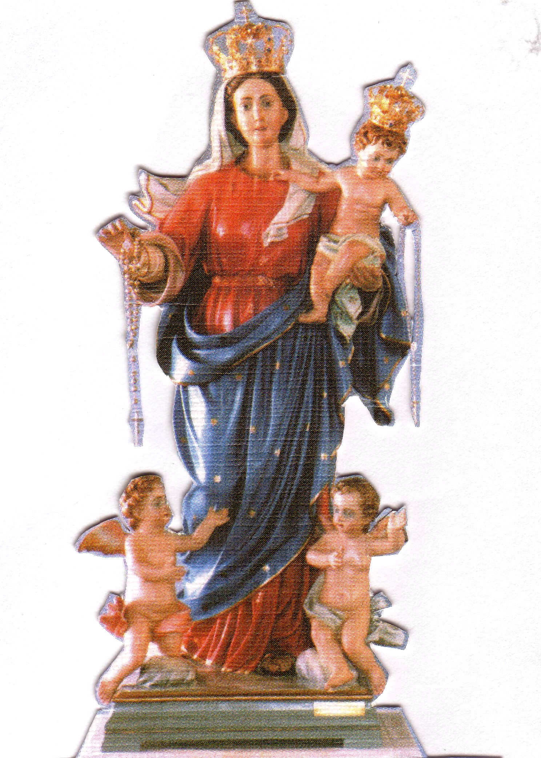
Nella nostra parrocchia di San Giuseppe Lavoratore
PROGRAMMA
Ore 2.00PM
Preghiere e Inni.
Processione con la statua
Recita del S. Rosario con i Misteri presentati dai bambini.
Ore 3.00PM Santa Messa concelebrata da Padre Aurelio Fragapane e Padre Emanuel Bonello,
Preghiera di affidamento alla Madonna.
Benedizione con il S.S.. Sacramento ai malati e famiglie.
Accompagnato dal coro di Holy Name con musicista Padre Raffaele Rossi

Anniversaries Continued…
Giovanni & Famiglia CALVI, Giovanni & Famiglia PAPALIA, Antonio DI GUGLIELMO,
Francesco VACIRCA, Domenico ALAGNA, Francesco MULTARI, Bruno MULTARI,Corrado PELLIGRA, Matteo NAPOLITANO, Antonio & Beniamino PASCUZZI,Giovanni LIROSI, Giuseppe GIARRATANA, Antonio CAPUTO, Giuseppe PINO, Raffaele SIRIANNI, Famiglia TOLINO, Giuseppe FATO,
Angela & Vincenzo CARESE, Raffaela, Domenico & Giuseppe CIANO, Giovanni CORDIANO,
Celestino BERTON, Nicola & Nino CORDIANO, Vincenzo, Alfredo, Francesco & Fidalma CIPOLLA, Domenico OCCHIUZZI, Antonietta MAIMIENDE,

