As we come and worship, we remember the wurundjeri people, the original custodians of this land

FIRST READING Genesis 2:18-24
They were two in one flesh.

RESPONSORIAL PSALM SALMO RESPONSORIALE
May the Lord bless us all the days of our lives. | Ci benedica il Signore tutti i giorni della nostra vita.
SECOND READING Hebrews 2:9-11
He who sanctifies and those who are sanctified have the same origin.

GOSPEL ACCLAMATION CANTO AL VANGELO
Alleluia, Alleluia!  If we love one another,  God will live in us in perfect love. Alleluia! | Alleluia Alleluia,  Se ci amiamo gli uni gli altri, Dio rimane in noi e l’amore di lui e’ perfetto in noi. Alleluia.
GOSPEL Mark 10:2-16
What God has joined together, no one must divide.

THANKS TO THOSE WHO GAVE LAST WEEK
1st Collection - Thanksgiving Offering…………………………..$651.00
- Loose Money…………………………………….$263.00
2nd Collection - Presbytery………………………………………..$347.00

PLEASE NOTE THAT THOSE WHO ARE ROSTERED ON TO READ OR GIVE COMMUNION AT MASS ARE KINDLY ASKED, IF POSSIBLE, TO ARRIVE 10 MINUTES BEFORE MASS STARTS
LECTORS - THIS WEEK 04/10/2015 SPECIAL MINISTERS
6.00pm (SAT) – MALTESE MASS (Selected) MALTESE MASS (Selected)
9.00am (SUN) – P Sparano & C Agostinelli M Piscioneri, G Calvi & M Forte
10.30am (SUN) – Sr Estelita & N Raveche A Filippone, J Frangiosa, L De Marco
J Kearney & R Gatto

LECTORS – NEXT WEEK 11/10/2015 SPECIAL MINISTERS
6.00pm (SAT) N Ziino & D Pullicino T Nguyen & E Krygger
9.00am (SUN) – R Pino & L Cavedon F Pascuzzi, G Tempone & C Alberti
10.30am (SUN) – E Thompson & L Conte A Gatto, J Iaria, J Kearney, D Herbert
S Rottura
MONEY COUNTERS 05/10/2015 S Dakin & D Herbert
12/10/2015 J & J Kearney, E Bartlett, C McMahon & S Dakin
YOUR PRAYERS ARE REQUESTED FOR THE FOLLOWING
RECENTLY DECEASED
John MENEGHINI, Bianca CAVALIERI

ANNIVERSARIES
Rae Maria BAMBARA, Antonio CIORRA, Luciano GRANIERI, Bartolo (Bob) PALAMARA,
Concetta GANCI, Agostino, Assunta & Angelo BRUNETTI, Famiglia DI TORO, Eddie DAKIN
Angelina & Michael BUTERA

ST JOSEPH THE WORKER
_______________________________________NORTH RESERVOIR _________________________________________

79 Wilson Boulevard, North Reservoir 3073

Parish House/Office Tel: 9460 3013 Fax: 9460 8832
Email: Parish@stjosephtheworker.org.au
www.stjosephtheworker.org.au
School Tel: 9469 7800 Fax: 9462 2949

SUNDAY MASS TIMES: Fr Emmanuel Bonello–Parish Priest WEEKDAY MASS TIMES:

Mb: 0431 643 674

Sat 6.00pm - English Sr Estelita Manabo-Pastoral Associate Mon. 9.10am Comm. Service
Sun. 9.00am - Italian Ms Marisa Steele -Acting School Principal Tue. 10.00am Italian

Sun. 10.30am – English Mrs Liz Pistoni – Parish Secretary Wed. 9.10am - English

Thur. 9.10am - English

Maltese Mass Fri. 9.10am - English Sat. 8.30am - English
1st Saturday of the Month 6.00pm Sat. 8.30am - English Sat. 8.30am-English
Baptisms – Sunday 12.00pm Reconciliation: Sat. 10.30am
Marriages - By Appointment

27th Sunday, Year B 4 October 2015
The D Word

In the reading from the gospel (Mark 1, 2-16) the Pharisees question Jesus about the lawfulness of divorce. Their question concerns only the rights of the man to divorce his wife, ignoring the rights of the woman. Jesus sets the record straight and in so doing directly challenges the cultural expectations of that era and indeed subsequent eras on the rights of women.
Jesus opens the debate by asking his adversaries about the teaching of Moses. The Pharisees reply correctly that Moses allowed the husband to write a certificate of divorce and send the woman out of his house. They have Moses on their side and assume they have won the argument. But Jesus replies this was not in accord with God’s original plan. The acceptance of divorce has crept into the Jewish tradition only because of the ‘hardness of the heart’ of the men whom the Pharisees represent. God’s original plan from the beginning of creation was different. In explaining this plan Jesus cites the text of the book of Genesis that we heard in today’s first reading.
God gives the first man to the first woman and gives the woman to the man, so that they become no longer two but one flesh; united in a loving union by God’s design. Having lost the argument, the Pharisees disappear. Jesus then continues the discussion with his disciples; The previous debate concerned divorce; Jesus now turns to the question of remarrying.
In the Jewish law there was no rule against divorce but Jesus gave a new interpretation of the law. However, there was a law against adultery. Jesus shows his disciples that disobedience to his interpretation of the law leads to the breaking of the law, because marrying another after divorce is committing adultery. A man who divorces his wife and marries commits adultery against his wife. The next verse (12) envisages the situation where a woman could divorce her husband; this was possible in Roman law and indicates that Mark was writing for a community that lived under that law. Jesus declares that a woman who divorces her husband commits adultery.
Jesus’ teaching on this topic is idealistic and is as difficult for people to accept today, as it was in his own time. The church must seek to uphold Jesus’ insistence on the equality of women and men in marriage and sustain couples in the difficulties they encounter. Sometimes marriages break-down and a civil divorce may be necessary to settle questions of finance and child custody. A divorce in such cases is not a sin and does not mean a person can no longer share in the life of the church. These and other ‘family’ issues will be addressed by the Synod of the Bishops on the Family that starts today and will continue until October 25.

WELCOME
We welcome in our Parish this weekend Mons. Archpriest Fr Carmelo Refalo, and Fr Simon Cachia from Gozo Malta. Mons Carmelo is the Parish Priest of Our Lady of Nativity Parish of Xaghra, Gozo, Malta which is the native Parish of Fr Manny. May both Frs. Carmelo and Simon enjoy their short time in Melbourne.

BIRTHDAY CELEBRATION – SR ESTELITA
Last Wednesday 30 September Sr Estelita celebrated her birthday. We ask God’s blessing upon her on this special occasion and pray for many years of health, happiness and peace.

BAPTISM
Congratulations to Rafael Santamaria son of Paul and Lucy, who will be baptised this weekend. We welcome him into our parish community and assure the family of our prayerful best wishes on this happy occasion

CUPPA

Next weekend after the 10.30am Mass there will be a cuppa in the Narthex. Please stop and
enjoy the hospitality of the parish.

FUNERAL
Rosary for Bianca Cavalieri will be recited on Monday 5 October at 11.00am followed by Funeral Mass.

MEMORIAL MASS
Tuesday 6 October 7.30pm – Rae Maria Bambara (1mth)

FEAST
Wednesday 7 October – Our Lady of the Rosary

MARY MACKILLOP MUSEUM
The Mary Mackillop Museum, at 362 Albert St, East Melbourne, will be open to the public on Saturday 10 October from 10.00am – 4.00pm. A guided Mary Mackillop walking tour will take place at 11.00am. The museum, chapel and gift shop will be open and Devonshire Tea will be available between 10.30am and 12pm.

OCTOBER THEOLOGY AT THE PUB WITH THE NEWLY ORDAINED
Monday 5 October, dinner and drinks from 6.30pm, talk commences 7.30pm
Pumphouse Hotel, 128 Nicholson Street, Fitzroy
This year the Archdiocese of Melbourne has had the joy of witnessing the ordination of nine men to the priesthood. Living in a society which places little value on both faith and lifelong commitment, these men have made a choice which is as countercultural as it is radical. Furthermore, with the priesthood no longer held in high esteem as it once was due to revelations of sexual abuse by a small number of the clergy, their decision provokes further amazement and confusion among our contemporaries. T@P (Theology at the Pub) welcomes the recently ordained Fr Joel Peart to speak on his call to the priesthood. With a combination of personal testimony and Catholic theology, Fr Joel will also touch on issues pertaining to the discernment of our own personal vocation in the midst of an increasingly secularised world. So come along and listen and have a drink with the down-to-earth Fr Joel. Avid motorcycle riders are welcome too and might find in Fr Joel a kindred spirit.
Target audience: 18 to 35 years olds; priests, deacons and religious of all ages welcome
Details: Andrew on 0403 239 543 or Fabio on 0432 995 322 or www.facebook.com/groups/tapmelb/

SOLENNE CELEBRAZIONE ALLA VERGINE DEL S. ROSARIO DOMENICA 4 OTTOBRE
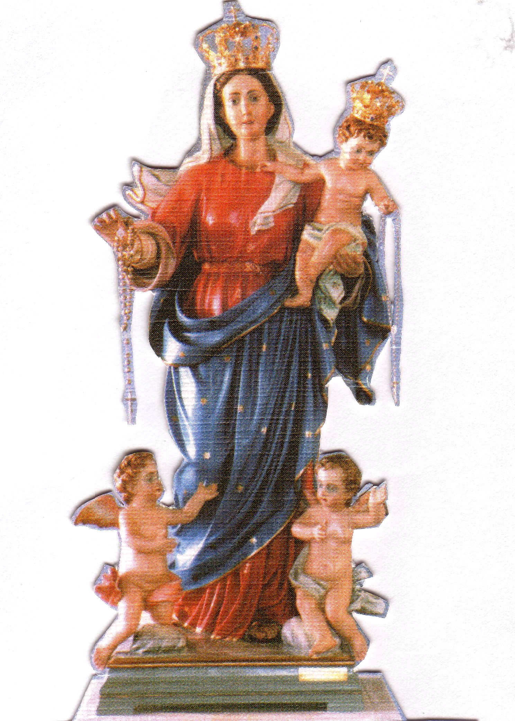
Nella nostra parrocchia di San Giuseppe Lavoratore
PROGRAMMA
Ore 2.00PM
Preghiere e Inni.
Processione con la statua
Recita del S. Rosario con i Misteri presentati dai bambini.

Ore 3.00PM
Santa Messa
concelebrata con Monsignor Carmelo Refalo da Malta,
Padre Emanuele Bonello e Padre Giuseppe Yu.
Preghiera di affidamento alla Madonna.
Benedizione con il S.S.. Sacramento ai malati e famiglie.
Accompagnato dal coro di Holy Name con musicista Padre Raffaele Rossi.

EXTRAORDINARY JUBILEE YEAR OF MERCY “TASTE AND SEE”

Pope Francis has invited us all to embark on a Jubilee Year to deepen our understanding of mercy as a church and society. The Year begins on December 8th and will go until 20th November 2016. The Archbishop Office for Evangelisation will hold a workshop day introducing the Year of Mercy. This will be a Year of Mercy planning day to be held on Saturday 17th October 2015 from 10am – 3pm at the Catholic Leadership Centre in East Melbourne. Cnr. Hoddle St and Victoria Pde. (It’s easily accessible by public transport and there’s street parking nearby.) The day includes a keynote presentation by international guest Margaret Silf, author and spiritual director from the UK, followed by workshops unpacking the themes of the Year. There will also be a showcase of resources to help parishes think about how they can participate. This workshop day is useful to priests, pastoral associates, members of Pastoral and Liturgy team. Any parishioner is welcome to attend. Please let Fr. Manny know if you wish to attend. Fr. Manny will be attending. This day will help us as a parish to participate and acknowledge the Year of Mercy next year.

JCMA FRIENDSHIP WALK
Sunday 11 October, 2pm St Peter’s Eastern Hill, 15 Gisborne Street, East Melbourne
Come along and spend an afternoon walking together in friendship and goodwill between a church, a synagogue and a mosque. Starting at St Peter’s Eastern Hill Anglican Church, we will walk across the road to the East Melbourne Hebrew Congregation Synagogue and then on to the Albanian Mosque in Carlton North. We will start with reflections and a prayer of peace and learn about some of the history and traditions of each of the places we visit.
Meeting place and planned walking route: 2pm: St Peter’s Eastern Hill with Father Hugh Kempster, 15 Gisborne Street (corner of Albert St), East Melbourne 2.30pm: East Melbourne Hebrew Congregation Synagogue with Rabbi Dovid Gutnick, 488 Albert Street, East Melbourne
3.50pm: Albanian Mosque with Imam Dr Bekim Hasani, 765 Drummond St, Carlton North
For further details and a map of the planned walking route, go to the ‘Walking Maps’ webpage: http://walkingmaps.com.au/walk/2194. Please arrive at 1.45pm and meet in the car park beside the church at St Peter’s Eastern Hill. Registration: http://www.eventbrite.com/o/jewish-christian-muslim-association-8450449956?s=44347253
Details: Ginette on 9287 5590 or 0400 211 221 or executiveofficer@jcma.org.au

