As we come and worship, we remember the wurundjeri people, the original custodians of this land

FIRST READING Chronicles 36:14-16, 19-23
The wrath and the mercy of the Lord are revealed in the exile and liberation of his people.

RESPONSORIAL PSALM SALMO RESPONSORIALE
Let my tongue be silenced, if I ever forget you. | Il ricordo di te, Signore, e’ la nostra gioia.
SECOND READING Ephesians 2:4-10
When we were dead through sins, he brought us to life.
.

GOSPEL ACCLAMATION CANTO AL VANGELO
Glory and praise to you, Lord Jesus Christ!  God loved the world so much, he gave us his only Son, that all who believe in him might have eternal life.  Glory and praise to you, Lord Jesus Christ! | Lode e onore a te, Signore Gesu’!  Dio ha tanto amato il mondo da dare il Figlio unigenito; chiunque crede in lui ha la vita eterna.  Lode e onore a te, Signore Gesu’!
GOSPEL John 3:14-21
God sent his Son into the world that we might be saved through him..

THANKS TO THOSE WHO GAVE LAST WEEK
^{st} Collection - Thanksgiving Offering…………………………..$350.00
- Loose Money…………………………………….$296.00
2nd Collection - Presbytery………………………………………..$240.00

PLEASE NOTE THAT THOSE WHO ARE ROSTERED ON TO READ OR GIVE COMMUNION AT MASS ARE KINDLY ASKED, IF POSSIBLE, TO ARRIVE 10 MINUTES BEFORE MASS STARTS

LECTORS - THIS WEEK 10/03/2024 SPECIAL MINISTERS
5.30pm (SAT) – E Saliba T Nguyen & B Nadenbousch
9.00am (SUN) – C Brunetti & G Barbaro P Sparano, M Sinopoli & P Leggiero
10.30am (SUN) – B Clark-Loh G Caruana & S Rottura
LECTORS – NEXT WEEK 17/03/2024 SPECIAL MINISTERS
5.30pm- E Kygger N Ziino & E Saliba
9.00am- T Forte & G Calvi D Biasibetti, R Pino & P Leggiero
10.30am- N Sua B Clark-Loh V De Leo

YOUR PRAYERS ARE REQUESTED FOR THE FOLLOWING RECENTLY DECEASED
Roldan ASIS,
ANNIVERSARIES & SPECIAL MEMORIES
Paolo PORCU, Vincenzo D’ANIELLO, Harold KENNAN, Fr Joseph YU

ST JOSEPH THE WORKER
_______________________________________NORTH RESERVOIR _________________________________________

79 Wilson Boulevard, North Reservoir 3073

Parish House/Office Tel: 9460 3013 Fax: 9460 8832
Email: reservoirnorth@cam.org.au
www.stjosephtheworker.org.au
School Tel: 9469 7800 Fax: 9462 2949

SUNDAY MASS TIMES: Fr Emmanuel Bonello–Parish Priest WEEKDAY MASS TIMES:

Mb: 0431 643 674

Sat 5.30pm - English Mrs Maria Barnes – School Principal
Sun. 9.00am - Italian Mrs Liz Pistoni – Parish Secretary Tue. 10.00am Italian

Sun. 10.30am – English Wed. 9.10am - English

Thur. 9.10am - English

Maltese Mass Fri. 9.10am - English Sat. 8.30am - English
1st Saturday of the Month 5.30pm Sat. 8.30am-English
Baptisms – Sunday 12.00pm Reconciliation:
Marriages – by Appointment (Individual Confessions)
Sat. 5.00pm or by Appointment

4th Sunday of Lent Year B 10 March, 2024
NEVER GIVE UP BECAUSE GOD DOESN’T
.
The 4th Sunday of Lent is traditionally known as Laetare Sunday, so called because of the first word “Rejoice” in the Entrance Antiphon of the liturgy. Laetare is a Latin word that means “rejoice.” Midway on our long Lenten journey to Easter, our energy and enthusiasm may well be flagging. Today’s readings remind us of the source of our joy as Christians and prompt us to renew our resolve and to persevere for the rest of the journey. In the gospel, we hear the reason for our rejoicing: “God loved the world so much that he gave his only Son” (John 3:16).
In the Old Testament, from Genesis on, the constant thread in all the books is the steadfast love that God has for God’s people. No matter how many times the people and their leaders faltered in their faith and hope in God, from Exodus to the Prophets, like Isaiah and Jeremiah, to the Kings, such as David and Solomon, and in the time of the Exile in Babylon after Jerusalem was besieged and captured and the people were exiled from Israel, God stood by and cared for the people and, each time they wavered and fell, God called them back and reminded them to try again and be faithful.
In the reading from John’s gospel, we learn about Nicodemus, a prominent member of Jewish society, who wanted to speak to Jesus but, perhaps afraid or confused or embarrassed, went to meet him under the cover of darkness. He was an admirer of Jesus but he was unsure about who Jesus really was: Did Jesus really perform miracles and was he the Messiah?
Jesus reveals to Nicodemus the astonishing truth at the heart of our faith and the source of our joy: “God loved the world so much that he gave his only Son . . . God did not send his Son into the world to condemn the world, but to save the world through him.” In Jesus, this overflowing super-abundant love of God for the world is revealed in its unsurpassable fullness. He is the Light of the World. No amount of darkness will ever be able to cover it or shroud it.
So, as we continue to journey through this Lenten period, let us stop for a moment on this Laetare Sunday, to marvel, celebrate, give thanks, and rejoice in God’s abundant and faithful love that continues to overflow in and around us in spite of the many troubles in the world. We may waver in our hope and faith, but God will never give up on us, even when we give up on ourselves and lose hope. God so loved the world that he gave his only Son. The gift of God’s Son was the ultimate gift of love. Let us rejoice! And let us press on with our Lenten journey.
Mark Chia CSsR

PROJECT COMPASSION
FOURTH SUNDAY OF LENT CARITAS AUSTRALIA

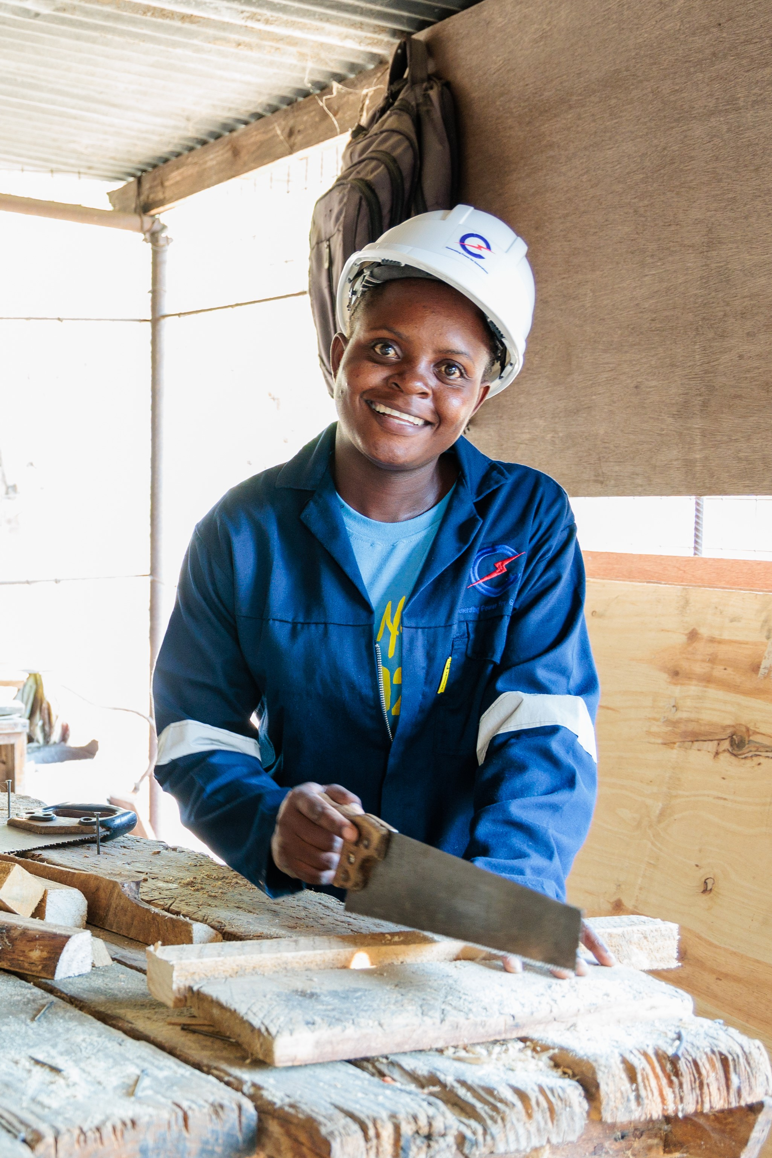
Memory is 26 years old and lives in rural Malawi. As the eldest child in a low-income farming family, Memory had to take on many household chores and farming activities to support her parents. They struggled to pay for Memory’s school fees and school supplies, and Memory often had to walk to school barefooted. With the support of Caritas Australia and its partner the Catholic Development Commission in Malawi (CADECOM), Memory was able to enrol at a technical college where she learnt technical skills in carpentry. She undertook a three-year carpentry course, with CADECOM supporting part of her tuition and boarding fees. Memory became the first female carpenter from her village. Today, she works as a carpenter at one of Malawi’s largest hydroelectric power stations. With the income from her job, she can provide financial support to her family and inspire other young women in her community so that they may have the opportunity to succeed in a male-dominated industry. Please donate to Project Compassion. Together, we can help vulnerable communities face their challenges today and build a better tomorrow, for all future generations. You can donate through Project Compassion donation boxes and envelopes available from your parish, by visiting caritas.org.au/project-compassion or by calling 1800 024 413.

VIA CRUCIS – STATIONS OF THE CROSS PRAYERS
Every Friday during Lent there will be Stations of the Cross Prayers, (English and Italian) after the 9.10am morning mass.

DAY PRAYERS FROM 2024 LENT PRAYER CALENDAR ( MARCH 9 - 16)
Saturday March 9: Pray for Eternal Life
Sunday March 10: Pray for Gentleness
Monday March 11: Pray for Servanthood
Tuesday March 12: Pray for Acceptance
Wednesday March 13: Pray for Repentance
Thursday March 14: Pray for Mercy
Friday March 15: Pray for Humility
Saturday March 16: Pray for Respect

HAND SANITISING FOR SAFETY PRACTICES
As in many other places for people to sanitise their hands, please know that “Hand Sanitiser Bottles” a re available in the Church, at the entrance and side doors and at the seats on the way to receiving communion. When you go to receive communion, please sanitise your hands and receive communion Only on the Hand. Please feel free, if you wish to wear a mask. THANKS.

MASS ON C31 (d.44)
For those unable to attend church due to illness or other reasons there is an opportunity to follow the 11.00am Sunday Mass from St. Patrick’s Cathedral, Melbourne, which is broadcast live on the TV station C31 Melbourne, which is channel 44 on digital TV.

The Parish of St Joseph the Worker, North Reservoir and the Diocese of Melbourne are committed to the care, wellbeing and protection of children, young people and vulnerable people in our community.

Holy Week and Easter Time Table 2024

WEDNESDAY 20th MARCH 2024:
10.30am Chrism Mass (Mass of the Holy Oils) at St. Patrick’s Cathedral, celebrated by Archbishop Peter Comensoli and priests of Melbourne. Everyone is welcome to attend.

SUNDAY 24TH MARCH 2024: PALM SUNDAY
Blessing of Palms or other branches during each Mass of that Weekend. Please bring Your Own Palms or Olive branches or another kind of branch.

WEDNESDAY 27TH MARCH 2024 :
7.00pm Communal Celebration of Reconciliation.

THURSDAY 28TH MARCH 2024: HOLY THURSDAY
7.00pm Mass of the Lord’s Supper.

FRIDAY 29TH MARCH 2024: GOOD FRIDAY
3.00pm Good Friday Ceremonies: Celebration of the Lord’s Passion
7.00pm Via Crucis (Stations of the Cross) in Italian and English.

SATURDAY 30TH MARCH 2024: HOLY SATURDAY
7.30pm Easter Vigil Celebration of Mass

SUNDAY 31ST MARCH 2024: EASTER SUNDAY
9.00am Mass in Italian, 10.30am Mass in English

INDIVIDUAL CONFESSIONS (CONFESSIONI INDIVIDUALI)

Tuesday 26th March 2024: 9.30am, Wednesday 27th March 2024: 9.30am,
Thursday 28th March 2024: 6.30pm, Friday 29th March 2024: 2.30pm, Saturday 30th March 2024: 7.00pm


MERCY HEALTH CARE FIRST
At Mercy Place Keon Park, caring for you is our top priority.
Our qualified and compassionate aged care teams tailor care according to your personal interests and needs, providing you with comfort and assurance. Our goal is simple: to enable you to have the best day possible, each and every day. Call us now on 1300 372 616 to book a tour. We look forward to welcoming you into your new home.
Mercy Place Keon Park, 15 Tunaley Parade, Keon Park, Vic 3073|
mercyhealth.com.au


MISSION: TRASFORM LIVES:-THEIRS AND YOURS.
Communities in Africa, Asia, Australia and the Pacific are looking for qualified and experienced Australians from ALL sectors to share their skills with those who have had little opportunity for formal training. You too will learn and grow within a most welcoming community. Experience the joy as you assist to change lives. Learn more: Join our Mission Webinar March 5 th, 2024, 6:00 - 6:30 pm. 63 years preparing Australians for enduring global relationships to build sustainable, self-reliant, community development. Learn Even More: Join our two-week tour to Timor-Leste on 06/05/2024 to see Palms program participants our local partner communities in action together. Contact: 02 9560 5333 palms@palms

