As we come and worship, we remember the wurundjeri people, the original custodians of this land

FIRST READING Isaiah 50:4-7
I did not cover my face against insult and I know I will not be ashaed.

RESPONSORIAL PSALM SALMO RESPONSORIALE
My God, my God, why have you abandoned me? | Dio mio, Dio mio, perche’ mi hai abbandonato?
SECOND READING Philippians 2:6-11
He humbled himself to become like us and God raised him on high.
.
GOSPEL ACCLAMATION CANTO AL VANGELO
Praise to you, Lord Jesus Christ, king of endless glory!  Christ became obedient for us even to death, dying on the cross.  Therefore God raised him on high and gave him a name above all other names.  Praise to you, Lord Jesus Christ, king of endless glory! | Lode e onore a te, Signore Gesu’!  Cristo si e’ fatto obbediente fino alla morte, e a una morte di croce. Per questo Dio lo esalto’ e gli dono’ il nome che e’ al di sopra di ogni nome.  Lode e onore a te, Signore Gesu’!
GOSPEL Mark 14:1-15:47
Blessed is he who comes in the name of the Lord.

THANKS TO THOSE WHO GAVE LAST WEEK
^{st} Collection - Thanksgiving Offering…………………………..$443.00
- Loose Money…………………………………….$330.00
2nd Collection - Presbytery………………………………………..$215.00

PLEASE NOTE THAT THOSE WHO ARE ROSTERED ON TO READ OR GIVE COMMUNION AT MASS ARE KINDLY ASKED, IF POSSIBLE, TO ARRIVE 10 MINUTES BEFORE MASS STARTS

LECTORS - THIS WEEK 24/03/2024 SPECIAL MINISTERS
5.30pm (SAT) – N Ziino E Krygger & M Mizzi
9.00am (SUN) – C Agostinelli & F Multari A Sonza, L Calafiore & N Mercuri
10.30am (SUN) – H Joy Lopez T Nguyen & M Mizzi
LECTORS – NEXT WEEK 31/03/2024 SPECIAL MINISTERS
5.30pm- EASTER VIGIL (Selected) EASTER VIGIL (Selected)
9.00am- T Forte & R Pino F Multari, G Barbaro & O Strangis
10.30am- R Covello G Caruana & S Rottura

YOUR PRAYERS ARE REQUESTED FOR THE FOLLOWING RECENTLY DECEASED

ANNIVERSARIES & SPECIAL MEMORIES Josephine CORDINA
Pasquale VILLELLA, Micheal BUTERA, Francesco & Teresa BUTERA, Giuseppe FAZZARI
Saverio & Rosa NICOLAZZO, Pasquale & Michael BUTERA, Vincenzo D’ANIELLO,
Libero, Francesco & Antonio SANTOPIETRO, Pasquale TIMPANO, Mariagrzia MURDICA,
Giuseppe & Domenico MAMMONE, Elda ADDONA

ST JOSEPH THE WORKER
_______________________________________NORTH RESERVOIR _________________________________________

79 Wilson Boulevard, North Reservoir 3073

Parish House/Office Tel: 9460 3013 Fax: 9460 8832
Email: reservoirnorth@cam.org.au
www.stjosephtheworker.org.au
School Tel: 9469 7800 Fax: 9462 2949

SUNDAY MASS TIMES: Fr Emmanuel Bonello–Parish Priest WEEKDAY MASS TIMES:

Mb: 0431 643 674

Sat 5.30pm - English Mrs Maria Barnes – School Principal
Sun. 9.00am - Italian Mrs Liz Pistoni – Parish Secretary Tue. 10.00am Italian

Sun. 10.30am – English Wed. 9.10am - English

Thur. 9.10am - English

Maltese Mass Fri. 9.10am - English Sat. 8.30am - English
1st Saturday of the Month 5.30pm Sat. 8.30am-English
Baptisms – Sunday 12.00pm Reconciliation:
Marriages – by Appointment (Individual Confessions)
Sat. 5.00pm or by Appointment

Palm Sunday Year B 24 March, 2024
A kingdom of nuisances and nobodies

In 2006, Franciscan theologian Richard Rohr visited Australia and was interviewed on ABC Radio National’s “Religion Report”. At the time, I was particularly impressed by a point Rohr made in distinguishing between “Christianity” and “Churchianity”, where the first constituted a challenge to the prevailing wider societal mores and values, while the second supported the cultural status quo.
Whatever one may think of Rohr’s distinction between “Christianity” and “Churchianity”, it does open up a fruitful line for discussion of the meaning of Mark’s gospel. Written at a time when the Jesus movement was anything but part of the status quo, the gospel is culturally subversive. The problem that confronted the Markan Christians, as it does us today, is to steer a middle course between the twin tensions of conformity to cultural expectations and the vocation to be counter cultural (where necessary) in working for a better world. Mark’s Jesus proclaimed a new world order that would privilege the marginalised and the forgotten; or as Biblical scholars John Dominic Crossan and Tom Wright have variously called, “a kingdom of nuisances and nobodies”. In Mark’s gospel, Jesus is a man who haunts the fringes of society, fraternising with the marginalised, touching the untouchables, speaking to those with whom he should not speak and, thereby, breaking the taboos of his Jewish faith and the mores of the Greco-Roman culture. Positive interactions with Jesus are typically displayed by characters living on society’s margins – the “nobodies”; people who were of no consequence: the leper (1:40-45); the paralytic (2:1- 12); the deaf (7:31-37); the blind (8:22-26; 10:46- 52); the widow (12:41-44); as well as tax collectors and sinners (2:15). In his preaching, Jesus repeatedly criticises the abusive use of power by society’s wealthy and respectable authorities. And it is this critique of abusive power that eventually ends in Jesus’ arrest and execution as a rabble rouser and a criminal of the State. As Richard Rohr points out, Jesus was not an “insider” or a “company man” (Rohr, 2006); which is not to say that Jesus is an “outsider” per se. Mark’s Jesus is a reputable teacher and scholar – a man of some consequence – but he refuses to operate within the boundaries set by either the religious elites or civil authorities, the somebodies of “good society”. Indeed, he even refuses to stay dead! Mark’s Jesus is not interested in “Churchianity” — that is, sticking to rules that govern membership in the club or the “ekklesia” (assembly or church). He is a social reformer who seeks the company of those deemed to be “beyond the pale”; an agent of God who proclaims, not a kingdom of the wealthy and notable – the “somebodies” in society – but that of the poor, the forgotten, the “nuisances and nobodies” – and he calls his disciples to go to the margins and do the same. The final command in Mark’s gospel is the call to “return to Galilee” (16:7), to the dirt-poor farmers and fishers at the rural fringes of Roman Palestine.
Ian J Elmer


PROJECT COMPASSION
PALM SUNDAY CARITAS AUSTRALIA

As Project Compassion 2024 comes to an end, we want to thank you for your incredibly generous support throughout Lent. This year, we shared with you the story of three inspiring women from across the globe, who overcame challenges to complete their education, access water and find secure employment. With the support of compassionate people like you, they are now forging a path to a better future for their families and their communities. There is still time to donate! Together, we can help vulnerable communities face their challenges today and build a better tomorrow, for all future generations. Please donate to Project Compassion. You can donate through Project Compassion donation boxes and envelopes available from your parish, by visiting caritas.org.au/project-compassion or by calling 1800 024 413.

GOOD FRIDAY COLLECTION FOR THE HOLY LAND
The annual collection for the support of the church in the Holy Land will take place on Good Friday, March 29th. This collection promotes the missionary work of the Church in the Holy Land by providing welfare assistance to local Christians in areas such as health, education, employment, housing. Parishes, and orphanages. It is also used to maintain over 70 churches and shrines associated with the life of Jesus. Due to the ongoing war, the Church and people of the Holy Land are still struggling with reduced income due to fewer pilgrims and lower church attendance around the world. In 2023 Australian Catholics were once again extremely generous and were able to send to the Holy Land nearly $1.4 million ($1.4 million (2022). The reality for the Holy Land mission is that they will continue to face challenges financial and spiritual and so we again ask Catholics around the world again to be as generous as possible, with their financial support as well as the spiritual support. Please remember the Christians of the Holy Land on Good Friday. Thank you.

DAY PRAYERS FROM 2024 LENT PRAYER CALENDAR ( MARCH 23 - 28)
Saturday March 23: Pray for Reverence
Sunday March 24: Pray for Virtue
Monday March 25: Pray for Purity
Tuesday March 26: Pray for Integrity
Wednesday March 27: Pray for Tolerance
Thursday March 28: Pray for Contentment

HAND SANITISING FOR SAFETY PRACTICES
As in many other places for people to sanitise their hands, please know that “Hand Sanitiser Bottles” a re available in the Church, at the entrance and side doors and at the seats on the way to receiving communion. When you go to receive communion, please sanitise your hands and receive communion Only on the Hand. Please feel free, if you wish to wear a mask. THANKS.

MASS ON C31 (d.44)
For those unable to attend church due to illness or other reasons there is an opportunity to follow the 11.00am Sunday Mass from St. Patrick’s Cathedral, Melbourne, which is broadcast live on the TV station C31 Melbourne, which is channel 44 on digital TV.

Holy Week and Easter Time Table 2024

WEDNESDAY 27TH MARCH 2024 :
7.00pm Communal Celebration of Reconciliation.

THURSDAY 28TH MARCH 2024: HOLY THURSDAY
7.00pm Mass of the Lord’s Supper.

FRIDAY 29TH MARCH 2024: GOOD FRIDAY
3.00pm Good Friday Ceremonies: Celebration of the Lord’s Passion
7.00pm Via Crucis (Stations of the Cross) in Italian and English.
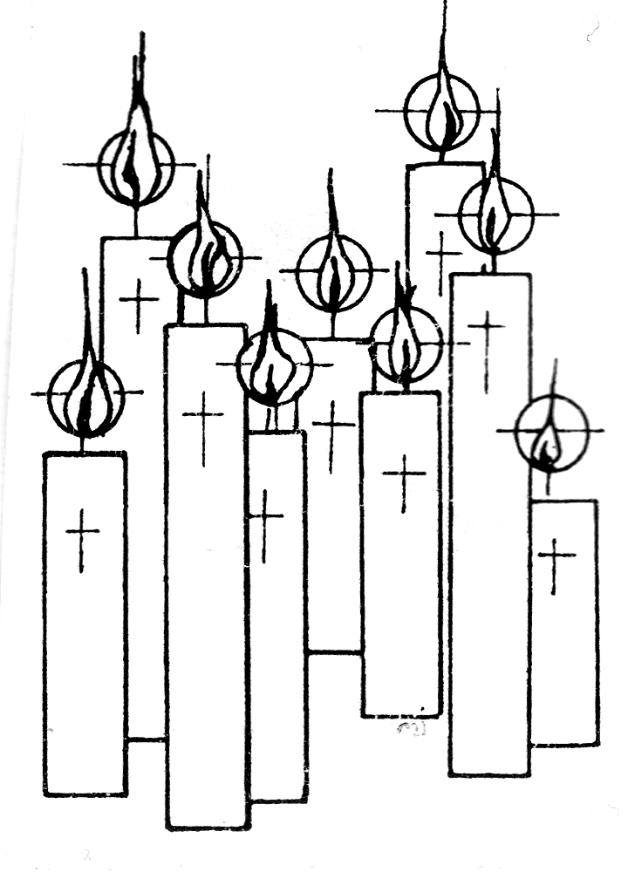
SATURDAY 30TH MARCH 2024: HOLY SATURDAY
7.30pm Easter Vigil Celebration of Mass

SUNDAY 31ST MARCH 2024: EASTER SUNDAY
9.00am Mass in Italian, 10.30am Mass in English

INDIVIDUAL CONFESSIONS (CONFESSIONI INDIVIDUALI)

Tuesday 26th March 2024: 9.30am
Wednesday 27th March 2024: 9.30am
Thursday 28th March 2024: 6.30pm
Friday 29th March 2024: 2.30pm
Saturday 30th March 2024: 7.00pm

ADORAZIONE EUCARISTICA
Martedi 26 Marzo : Adorazione Eucaristica ore 9.00am, Segue S. Messa ore 10.00am

ST PATRICK’S CATHEDRAL HOLY WEEK AND EASTER LITURGIES ON TV.
Some of the Holy Week and Easter Celebrations at St Patrick’s Cathedral will be Televised on the Television Community Channel C31 (Channel 44 on digital television).
The celebrations to be Broadcast on Television are:
Palm Sunday (24 March): 11am* Holy Thursday (28 March): 7.30pm*
Good Friday Ceremonies – The Passion of the Lord: (29 March): 3.00pm*
Easter Vigil (30 March): 7.30pm*
Easter Sunday (31 March): 11am*
Please note that these Celebrations will be also livestreamed on the Archdiocesan YouTube Channel (www.youtube.com/archmelb)


MERCY HEALTH CARE FIRST
At Mercy Place Keon Park, caring for you is our top priority.
Our qualified and compassionate aged care teams tailor care according to your personal interests and needs, providing you with comfort and assurance. Our goal is simple: to enable you to have the best day possible, each and every day. Call us

The Parish of St Joseph the Worker, North Reservoir and the Diocese of Melbourne are committed to the care, wellbeing and protection of children, young people and vulnerable people in our community.

