As we come and worship, we remember the wurundjeri people, the original custodians of this land

FIRST READING Amos 8:4-7
The Lord spoke against those who buy the poor for money.

RESPONSORIAL PSALM SALMO RESPONSORIALE
Praise the Lord, who lifts up the poor. | Benedetto il Signore che rialza il povero.
SECOND READING Timothy 2:1-8
Let prayers be offered to God for everyone; he wants all people to be saved.

GOSPEL ACCLAMATION CANTO AL VANGELO
Alleluia, alleluia!  Jesus Christ was rich but he became poor,  to make you rich out of his poverty. Alleluia! | Alleluia, alleluia.  Gesu’ Cristo, da ricco che era, si e’ fatto povero per voi, perche’ voi diventaste ricchi per mezzo della sua poverta’. Alleluia!
GOSPEL Luke 16: 1-13
You cannot be slaves both of God and of money.

THANKS TO THOSE WHO GAVE LAST WEEK
1st Collection - Thanksgiving Offering…………………………..$838.00
- Loose Money…………………………………….$179.00
2nd Collection - Presbytery………………………………………..$234.00
Father’s Day Appeal - ……………………………………………….$449.00

PLEASE NOTE THAT THOSE WHO ARE ROSTERED ON TO READ OR GIVE COMMUNION AT MASS ARE KINDLY ASKED, IF POSSIBLE, TO ARRIVE 10 MINUTES BEFORE MASS STARTS
LECTORS - THIS WEEK 18/09/2016 SPECIAL MINISTERS
6.00pm (SAT) – E Krygger & D Pullicino S Dakin & E Saliba
9.00am (SUN) – L Cavedon &B R Pino M Forte, G Tempone & C Alberti
10.30am (SUN) – L & L De Marco A Filippone, J Frangiosa & J Iaria

LECTORS – NEXT WEEK 25/09/2016 SPECIAL MINISTERS
6.00pm (SAT) B Nadenbousch & E Saliba R Iuele & P Nguyen
9.00am (SUN) – R Fato & C Agostinelli P Sparano, R Pino & L Cavedon
10.30am (SUN) – N Sua & E Thompson A & R Gatto, & B Clark-Loh
MONEY COUNTERS 19/09/2016 A Sinopoli, F Nardozza, I Manini & R Comito
26/09/2016 E Claridge, F Carabott & G Cananvan

YOUR PRAYERS ARE REQUESTED FOR THE FOLLOWING
RECENTLY DECEASED
Luigi CAVEDON, Joseph BUTTIGIEG (cousin of Fr Manny)

ANNIVERSARIES
Brian KRYGGER, Maria-Rosa CROCITTI, Caterina DAMIANO, Diana VINELLI, Antonio VILLELLA,
Francesco ROTTURA, Vincenzo AMERENA, John Thannickal JOSEPH, Giuseppe TARANTO,
Gina DI DONATO, Bartolo “Bob” PALAMARA, Giovanni, Lucia & Pasqualina MASCIOTRA,
Mazzio CONCETTA

ST JOSEPH THE WORKER
_______________________________________NORTH RESERVOIR _________________________________________

79 Wilson Boulevard, North Reservoir 3073

Parish House/Office Tel: 9460 3013 Fax: 9460 8832
Email: Parish@stjosephtheworker.org.au
www.stjosephtheworker.org.au
School Tel: 9469 7800 Fax: 9462 2949

SUNDAY MASS TIMES: Fr Emmanuel Bonello–Parish Priest WEEKDAY MASS TIMES:

Mb: 0431 643 674

Sat 6.00pm - English Sr Estelita Manabo-Pastoral Associate Mon. 9.10am Comm. Service
Sun. 9.00am - Italian Mrs Maria Barnes -School Principal Tue. 10.00am Italian

Sun. 10.30am – English Mrs Liz Pistoni – Parish Secretary Wed. 9.10am - English

Thur. 9.10am - English

Maltese Mass Fri. 9.10am - English Sat. 8.30am - English
1st Saturday of the Month 6.00pm Sat. 8.30am - English Sat. 8.30am-English
Baptisms – Sunday 12.00pm Reconciliation: Sat. 10.30am
Marriages - By Appointment
25th Sunday, Year C 18 September 2016
Cleverman

Cleverman is the heroic figure of a TV drama series. Cleverman lives between two worlds, representing a group of non-humans who battle for survival in a world where humans feel inferior and threatened. Cleverman is a ‘chosen’ one. He has special gifts and powers. The point of the drama is whether Cleverman can harness and exercise his powers before everything crumbles around him?
A similar drama is played out in today’s gospel passage. We meet a character pretending to play Cleverman. He is a rather slippery character; a servant about to be sacked for ‘fiddling’ his master’s accounts. What to do? He has to quickly come up with a plan to secure a future. He is aware of his limitations. He is not robust enough for labouring jobs; not humble enough to hold out a beggar’s bowl. Cleverman decides to ingratiate himself with his mater’s clients in the hope of gaining employment with them. He offers the master’s clients in the hope of gaining employment with them. He offers the master’s debtors huge discounts on their debts.
The master rues his losses. He has been defrauded. He assesses his situation. Grudgingly, he has to acknowledge the astuteness of his street-smart former employee. He rates Cleverman: morality-nil; cunning-ten. Jesus told this story for a purpose. It was not to encourage dishonesty but to challenge his followers to be as clever and astute in assuring their future with God, as Cleverman the steward was about security his prospects of employment.
We modern followers of Jesus live in challenging times. Secular culture is often dismissive of religon and derisive of Christian morality. We are tempted to retire into our shells and live somewhat timidly, if not tepidly. Or, take a path of least resistance and accept some of the false values of our society. In the end, we begin to become careless and somewhat indifferent to gospel values. We neglect the things of God. Jesus says that this is not a clever way to live. A smart way to live is to be drawn into the eternal embrace of our heavenly Father and be a privileged member of God’s family and to bring our human family into the embrace of God’s love. Jesus requires us to be Cleverman – spiritually street-smart. We do indeed need to acknowledge many of the good values of our contemporary world: security, personal achievement, relationships and social benefits among them. They are good in themselves but they are not an end in themselves. They are a means to the more critical goal of honouring God and loving our neighbour as ourselves. It takes a Cleverman – a spiritually astute person gifted with faith and love – to recognise this primacy of purpose; to get into action; to overcome timidity; to demonstrate that people are more important than things; that love is more important than success; that now is more pressing and important than the past. Jesus wishes every Christian to be a Cleverman.

FR MANNY ON HOLDAYS 4TH SEPTEMBER TO 1ST OCTOBER
Fr Manny will be away on holidays leaving Melbourne Sunday night 4th September and will return back Saturday morning 1st October. In the meantime Mons. Peter Kenny will celebrate the Weekends’ masses. Mons. Kenny will also celebrate the 10am mass on Tuesdays and also a mass at 10am on Fridays. We welcome Mons Peter Kenny and listen to his Scripture reflections as he celebrates with us the Eucharist.
Please Note
While Fr Manny is away (4th Sept – 1st Oct) during the week, masses will be celebrated on Tuesdays at 10am (Italian) and on Fridays at 10am (English). Communion Services will be held on Wednesdays and Thursdays at 9.10am. There will not be any communion services or masses on Mondays and Saturdays Morning.


CUPPA
This weekend after the 10.30am Mass there will be a Cuppa in the Narthex. Please stop and
enjoy the hospitality of the parish.

FUNERAL
Rosary for Luigi Cavedon will be recited on Sunday18 September at 7.00pm. Funeral Mass will be celebrated on Monday 19 September at 10.30am.

ITALIAN COMMITTEE
Martedi 20 Settembre, riunione dei membri del comitato per la preparazione della festa della Madonna del S. Rosario. Ore 9.00am in cappella. Segue S. Messa ore 10.00am.

MEMORIAL MASS
Saturday 24 September 6.00pm – Maria Olalla (1 mth)

FEASTs
Tuesday 20 September – Sts Andrew Kim Tae-gon & Paul Chong Ha-sang
Wednesday 21 September – St Matthew
Friday 23 September – St Pius of Pietreclina

THANKSGIVING ENVELOPES
The current series of Thanksgiving envelopes will end on Sunday 25 September.
A new series of Thanksgiving envelopes will be issued for the following six months and will be delivered to your homes within the next 2 weeks.
We ask parishioners who are not currently listed through Thanksgiving to please consider supporting the parish in this way. Please contact the Parish Office for further details on 9460 3013.

SOCIAL JUSTICE SUNDAY
We celebrate Social Justice Sunday on 25 September.
This year, the Australian Bishops’ Social Justice Statement is titled: ‘A PLACE AT THE TABLE: Social Justice in an Ageing Society’.
The Statement celebrates the value and dignity of older people in Australian life. It challenges us to recognise their significant contribution to society and emphasises that this contribution should not be valued in mere economic terms. The Statement calls for justice for those who are most vulnerable and warns about a view of older people as burdensome or dispensable.
For further details about the Social Justice Statement, visit the Australian Catholic Social Justice Council website www.socialjustice.catholic.org.au or call (02) 8306 3499.

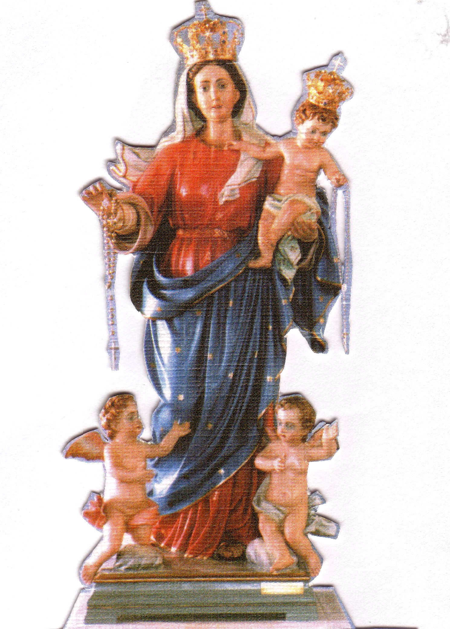
SOLENNE CELEBRAZIONE ALLA VERGINE DEL S. ROSARIO DOMENICA 2 OTTOBRE
Nella nostra parrocchia di San Giuseppe Lavoratore
PROGRAMMA
Ore 2.00PM
Preghiere e Inni.
Processione con la statua
Recita del S. Rosario con i Misteri presentati dai bambini.

Ore 3.00PM
Santa Messa
concelebrata da Padre Luciano Toldo e Padre Emanuel Bonello,
Preghiera di affidamento alla Madonna.
Benedizione con il S.S.. Sacramento ai malati e famiglie.
Accompagnato dal coro di Holy Name con musicista Padre Raffaele Rossi.

MISSIONARY SISTERS OF ST PETER CLAVER
“The Missionary Sisters of St Peter Claver will hold their Annual Mission Fair on Saturday 8 October 9.00am – 3.00pm, at 154 Cotham Road, Kew. This year the proceeds will assist a project initiated by Sr Amelia, Yendi, Ghana to enable women acquire various skills such as sewing, bread-making and soap-making. The eventual aim is to help them to set up a co-operative and generate income.
Enquiries Phone: 9817 3715.”

IS THE CHURCH HOMOPHOBIC?: DINNER DISCUSSION NIGHT
Sunday 25 September, 6.30–8.30pm
The Cunningham Centre, 64 Stanley Street, Ivanhoe
A friendly, engaging and interactive evening for 25 to 55 year olds. Pizza and a friendly chat will be followed by open discussion , led by Fr Paul Newton. The evening’s topic: ‘Is the Church homophobic?’
Details and RSVP: ivanhoe.emmaus@gmail.com by Friday 23 September.

MERCY IN THE CITY
Friday 30 September, 6pm
Sts Peter & Paul’s, Corner Dorcas and Montague Streets, South Melbourne
Young people of Melbourne are invited to a night of music and prayer at the first ever ‘Mercy In The City’. It will be a night celebrating the faith shared by young people here in Melbourne, as we draw closer towards the end of the Jubilee Year of Mercy.
Details: https://www.facebook.com/events/1089842791112469/
CELEBRATION OF THE MARIAN JUBILEE OF MERCY: A TRIDUUM
7–9pm, Friday 30 September; 2–5pm, Saturday 1 October; 2pm, Sunday 2 October
Our Lady of Ta’ Pinu Shrine, 15 Flanagans Drive, Bacchus Marsh
In preparation for the Feast of Our Lady, Queen of the Most Holy Rosary, the Marian shrine Our Lady of Ta’ Pinu is hosting a triduum, a three-day period of prayer. Devotions will begin on Friday with a night of reconciliation, including Mass. On Saturday, 2–5pm, First Saturday devotions to Mary will include the Rosary and Mass, along with a Eucharistic procession. On Sunday, the Feast of Our Lady of the Most Holy Rosary, Bishop Mark Edwards OMI will concelebrate Mass. The afternoon will include the crowning of Our Lady’s statue, Benediction and a Rosary procession. All welcome on any or all three days. Details: Josette Salomon on 0412 360 231 or 5367 7006

