As we come and worship, we remember the wurundjeri people, the original custodians of this land

FIRST READING Amos 6:1, 4-7
You who give yourself to licentiousness and revelry will be exiled..

RESPONSORIAL PSALM SALMO RESPONSORIALE
Praise the Lord, my soul. | Loda il Signore, anima mia.
SECOND READING Timothy 6:11-16
Obey the commandments until the coming of the Lord.

GOSPEL ACCLAMATION CANTO AL VANGELO
Alleluia, alleluia  Jesus Christ was rich but he became poor, to make you rich out of his poverty. Alleluia! | Alleluia, alleluia!  Gesu’ Cristo da ricco che era, si e’ fatto povero per voi, perche’ voi diventaste ricchi per mezzo della sua poverta’. Alleluia!
GOSPEL Luke 16:19-31
During your life good things came your way just as bad things came the way of Lazarus. Now he is being comforted while you are in agony.

THANKS TO THOSE WHO GAVE LAST WEEK
1st Collection - Thanksgiving Offering…………………………..$633.00
- Loose Money…………………………………….$372.00
2nd Collection - Presbytery………………………………………..$336.00

PLEASE NOTE THAT THOSE WHO ARE ROSTERED ON TO READ OR GIVE COMMUNION AT MASS ARE KINDLY ASKED, IF POSSIBLE, TO ARRIVE 10 MINUTES BEFORE MASS STARTS
LECTORS - THIS WEEK 29/09/2019 SPECIAL MINISTERS
6.00pm (SAT) –G Canavan & Sr T Fitzsimmons T Nguyen & E Saliba
9.00am (SUN) – F Multari & C Brunetti D Biasibetti, S Lobartolo, P Leggiero & L Calafiore
10.30am (SUN) – V De Leo & L Conte A Gatto, E Bartlett, J Mengolian & K Nguyen
LECTORS – NEXT WEEK 06/10/2019 SPECIAL MINISTERS
6.00pm (SAT) MALTESE MASS (Selected) MALTESE MASS (Selected)
9.00am (SUN) – F Pascuzzi & P Sparano T Mirigliano, L Catena, A Sonza & G Barbaro
10.30am (SUN) – H Joy Lopez & B Clark - Loh J Iaria, D Schembri, R Gatto & S Rottura
MONEY COUNTERS 30/09/2019 S Dakin
07/10/2019 S Dakin

YOUR PRAYERS ARE REQUESTED FOR THE FOLLOWING RECENTLY DECEASED
Ferruccio DI RICO, Novarro MERLI, Rosa DE ZAN, Emilia CICCONE, Maria COSTANZO
ANNIVERSARIES & SPECIAL MEMORIES
Charlie BONELLO, Patrick MAHONY, Mario AMERENA , Domenico CIRIANNI, Famiglia DI MUZIO, Francesco MUZZI, Carmelina RIZZO, Michael BUTERA, Bianca & Francesco CAVALIERI,
Felice TARANTO,

ST JOSEPH THE WORKER
_______________________________________NORTH RESERVOIR _________________________________________

79 Wilson Boulevard, North Reservoir 3073

Parish House/Office Tel: 9460 3013 Fax: 9460 8832
Email: Parish@stjosephtheworker.org.au
www.stjosephtheworker.org.au
School Tel: 9469 7800 Fax: 9462 2949

SUNDAY MASS TIMES: Fr Emmanuel Bonello–Parish Priest WEEKDAY MASS TIMES:

Mb: 0431 643 674

Sat 6.00pm - English Sr Estelita Manabo-Pastoral Associate Mon. 9.10am Comm. Service
Sun. 9.00am - Italian Mrs Maria Barnes -School Principal Tue. 10.00am Italian

Sun. 10.30am – English Mrs Liz Pistoni – Parish Secretary Wed. 9.10am - English

Thur. 9.10am - English

Maltese Mass Fri. 9.10am - English Sat. 8.30am - English
1st Saturday of the Month 6.00pm Sat. 8.30am - English Sat. 8.30am-English
Baptisms – Sunday 12.00pm Reconciliation: Sat. 10.30am
Marriages - By Appointment

26th Sunday in Ordinary Time Year C 29 September, 2019
God’s purpose for us

The words from today’s responsorial Psalm – ‘The Lord shall reign forever’ – proclaim a theme that is like a golden thread woven through the entire Bible, from beginning to end.
God created the world for a purpose. He redeems the world for that same purpose. Jesus reveals this purpose; he is the purpose. In him the Lord shall reign forever. That’s why we call Jesus the Alpha and Omega. By his teaching, and by his life, death and resurrection, Jesus reveals to us that God created humanity in the beginning with a special purpose in mind, a purpose born of love. This means that we ourselves have a purpose. And that purpose is articulated by these words of the Psalm: The Lord shall reign forever. How does this work?
The plan of God for the world and for humanity within it has unfolded over the millennia of human history through the life of a chosen people, the children of Abraham, who are chosen, elected by God, to collaborate in the accomplishment of God’s purpose.
The Bible is a vast library of books, built up through those millennia, telling of the relationship – called a covenant – of companionship and collaboration with God. From Adam to Jesus the covenants which God has forged with human partners form a developing series.
The Bible describes five central covenants made between God and humans:
The covenant with all creation through Noah,
The covenant of election with Abraham,
The national covenant with the people of Israel through Moses,
The royal covenant with David, and
The new covenant of Jesus the Messiah.
As the biblical story unfolds it becomes clear that the common purpose of the covenants is, to us Jesus’ expression, the Kingdom. It is also clear that the covenants are so intimately interconnected that they effectively constitute one covenant unfolding in five stages. Through them God reveals and shares God’s purpose with us, who among all God’s creatures are uniquely called to collaborate in bringing about God’s reign.
So the unity of the biblical story is found in the theme of the reign of God, the Kingdom, and its accomplishment which unfolds through the stages of God’s covenantal companionship and collaboration with humanity, culminating in the life, death and resurrection of Jesus.
Once again Jesus highlights that God’s steadfast love and paramount concern is for the poor and oppressed, the marginalized and the lost. So it should be for us, his followers.
W Chris Hackett

MONDAY COMMUNION SERVICE
Please note that there will not be any Communion Service for Monday 30 September due to School holidays. Church will remain closed.

FUNERALS
Rosary for Novarro Merli will be recited on Tuesday 1 October at 11.30am followed by Funeral Mass.

Rosary for Rosa De Zan will be recited on Wednesday 2 October at 10.30am followed by Funeral Mass.

Funeral Mass for Emilia Ciccone will be celebrated on Wednesday 2 October at 1.30pm.

Rosary for Maria Costanzo will be recited on Wednesday 2 October at 6.30pm. Funeral Mass will be celebrated on Thursday 3 October at 10.30am.

MEMORIAL MASS
Monday 30 September 7.00pm – Mario Amerena (1mth)

ITALIAN COMMITTEE
Martedi 1 Ottobre, riunione dei membri del comitato per la preparazione della festa della Madonna del S. Rosario. Ore 9.00am in cappella. Segue S. Messa ore 10.00am.

MALTESE MASS
A reminder that the Maltese Mass will be celebrated on Saturday 5 October at 6.00pm.

FEASTS
Monday 30 September – St Jerome - Tuesday 1 October – St Therese of the Child Jesus
Wednesday 2 October – The Holy Guardian Angels - Friday 4 October – St Francis of Assisi

SOCIAL JUSTICE SUNDAY
This weekend, Sunday 29th September 2019 is SOCIAL JUSTICE SUNDAY and the Australian Bishops’ Social Justice Statement for 2019-20 is called ‘Making it Real: Genuine human encounter in our digital world’. The bishops affirm the positive possibilities for encounter and solidarity offered by new digital media, while warning of those elements that may be harmful. With the friendship of the Good Samaritan as our inspiration, we are called to “make real” the love of God in the virtual neighbourhood.
Lord, make us instruments of your peace. Help us to recognise the evil latent in a communication that does not build communion. Help us to remove the venom from our judgements. Help us to speak about others as our brothers and sisters. You are faithful and trustworthy; may our words be seeds of goodness for the world:
Where there is shouting, let us practise listening; where there is confusion, let us inspire harmony; where there is ambiguity, let us bring clarity; where there is exclusion, let us offer solidarity; where there is sensationalism, let us use sobriety; where there is superficiality, let us raise real questions; where there is prejudice, let us awaken trust; where there is hostility, let us bring respect; where there is falsehood, let us bring truth.
Amen. (- A Prayer from Pope Francis, 2018 -) more on www.socialjustice.catholic.org.au
Copies of Statement, Ten steps Leaflets and Prayer Cards are available in the Narthex and next to the Side Door of the Church.

THANKSGIVING ENVELOPES
The current series of Thanksgiving envelopes end this weekend.
A new series of Thanksgiving envelopes have been issued for the following six months and will be delivered to your homes within the next week.
We ask parishioners who are not currently listed through Thanksgiving to please consider supporting the parish in this way. Please contact the Parish Office for further details on 9460 3013.
We invite those parishioners who distribute the Thanksgiving envelopes to please collect your allocated streets from the sacristy. The distributors are as follows: B Nadenbousch, P Sparano, J Barbaro, S Ciantar, R Di Berardino
R Di Guglielmo, D Cipollone, R Catena, P Caligiuri, P Leggiero, A Filippone, N Ziino & V Zele.

SOLENNE CELEBRAZIONE ALLA VERGINE DEL S. ROSARIO
DOMENICA 6 OTTOBRE 2019
Nella nostra parrocchia di San Giuseppe Lavoratore
PROGRAMMA
Ore 2.00PM
Preghiere e Inni.
Processione con la statua
Recita del S. Rosario con i Misteri Meditati
Ore 3.00PM
Santa Messa concelebrata da Padre Aurelio Fragapane e Padre Emanuel Bonello,
Preghiera di affidamento alla Madonna.

“Vi invitiamo di portare una foto dei vostri nipoti che sara’ posia intorno alla Madre Celeste per una benedizione speciale.”

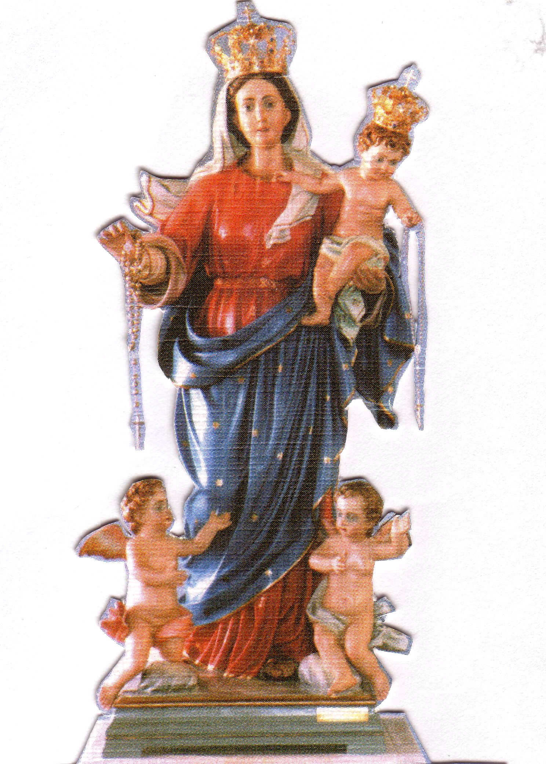
Benedizione con il S.S.. Sacramento ai malati e famiglie.
Accompagnato dal musicista Monsignor Raffaele Rossi

OUR LADY OF THE HOLY ROSARY SUNDAY 6 OCTOBER 2019
PROGRAM:
2.00pm - Prayers & Procession with the Statue of Our Lady. Mysteries of the Rosary Meditated.
3.00pm - Holy Mass concelebrated by Fr Aurelio Fragapane & Fr Emmanuel Bonello
Musician: Rev. Raffaele Rossi
Benediction for the sick and families. The Children will be entrusted to the maternal protection of Mary.

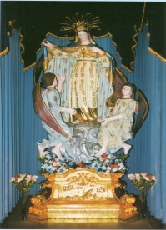
FEAST OF STELLA MARIS

FRIDAY 18 OCTOBER:
6.30pm: Confessions in English and Maltese will be heard at St. Joseph the Worker Church.
7.00pm: Mass celebrated by Rev. Fr Frank Buhagiar
There will be presentation of flowers to Our Lady.
After Mass everyone is invited to join us for some refreshments.
SATURDAY 19 OCTOBER:
6.30pm: Feast Dinner Dance will be held at Emerald Receptions. DJ Domenic will be entertaining us on the night. Later on in the night the Maltese United Brass Band will join us to entertain us playing various joyous marches.
SUNDAY 20 OCTOBER:
2.30pm: High Mass: Celebrated by Mons. Anton Portelli, assisted by Canon Manuel Bonello, Rev Fr Frank Buhagiar, Rev Fr Lonnie Borg assisted by Desmond Calleja. And the Stella Maris Choir. All Associations are invited to take part by joining us in the church celebrations as well as during the procession carrying their banners.
4.00pm: The procession with the beautiful Statue of Stella Maris will commence. The Maltese Own Band Philharmonic Society Inc and the MMG concert band of Vic. Will accompany the statue around the streets
of the Church.
6.00pm: After the procession everyone is welcome to come in the Hall where the two Maltese Bands will perform. Afterwards there will be DJ Domenic to entertain us.

THERE WILL BE FOOD AND DRINKS FOR SALE. EVERYONE IS WELCOME.
THE COMMITTEE WISHES EVERYONE A GOOD TIME DURING THESE FESTIVITIES.

