As we come and worship, we remember the wurundjeri people, the original custodians of this land

FIRST READING Habakkuk 1:2-3; 2:2-4
The just will live by faithfulness.

RESPONSORIAL PSALM SALMO RESPONSORIALE
If today you hear his voice, harden not your hearts. | Ascoltate oggi la voce del Signore.
SECOND READING Timothy 1:6-8, 13-14
Never be ashamed of witnessing to the Lord.

GOSPEL ACCLAMATION CANTO AL VANGELO
Alleluia, alleluia  The word of the Lord stands for ever: it is the word given to you, the Good News. Alleluia! | Alleluia, alleluia!  La parola del Signore rimane in eterno: e questa e’ la parola del Vangelo che vi e’ stato annunciato. Alleluia!
GOSPEL Luke 17:5-10
If you had faith!

THANKS TO THOSE WHO GAVE LAST WEEK
1st Collection - Thanksgiving Offering…………………………..$447.00
- Loose Money…………………………………….$378.00
2nd Collection - Presbytery………………………………………..$226.00

PLEASE NOTE THAT THOSE WHO ARE ROSTERED ON TO READ OR GIVE COMMUNION AT MASS ARE KINDLY ASKED, IF POSSIBLE, TO ARRIVE 10 MINUTES BEFORE MASS STARTS
LECTORS - THIS WEEK 06/10/2019 SPECIAL MINISTERS
6.00pm (SAT) –MALTESE MASS (Selected) MALTESE MASS (Selected)
9.00am (SUN) – F Pascuzzi & P Sparano T Mirigliano, L Catena, A Sonza & G Barbaro
10.30am (SUN) – H Joy Lopez & B Clark-Loh J Iaria, D Schembri, R Gatto & S Rottura
LECTORS – NEXT WEEK 13/10/2019 SPECIAL MINISTERS
6.00pm (SAT) E Saliba & B Nadenbousch E Krygger & T Nguyen
9.00am (SUN) – G Tempone & G Calvi O Strangis, M Crupi & T Forte
10.30am (SUN) – Sr Estelita & R Covello S Dakin, L De Marco, A Filippone & R Iuele
MONEY COUNTERS 07/10/2019 S Dakin
14/10/2019 E Bartlett

YOUR PRAYERS ARE REQUESTED FOR THE FOLLOWING RECENTLY DECEASED
Nunziata ZIINO
ANNIVERSARIES & SPECIAL MEMORIES
Eddie DAKIN, Gaetano ATTARDO, Domenico CARUSO, Giuseppe ZAPPONE, Ferruccio DI RICO
Salvatore & Sofia RACHIELE, Antonio & Filomena PISANI, Gaetano CARMUSCIANO
Rocco LAGANA

ST JOSEPH THE WORKER
_______________________________________NORTH RESERVOIR _________________________________________

79 Wilson Boulevard, North Reservoir 3073

Parish House/Office Tel: 9460 3013 Fax: 9460 8832
Email: Parish@stjosephtheworker.org.au
www.stjosephtheworker.org.au
School Tel: 9469 7800 Fax: 9462 2949

SUNDAY MASS TIMES: Fr Emmanuel Bonello–Parish Priest WEEKDAY MASS TIMES:

Mb: 0431 643 674

Sat 6.00pm - English Sr Estelita Manabo-Pastoral Associate Mon. 9.10am Comm. Service
Sun. 9.00am - Italian Mrs Maria Barnes -School Principal Tue. 10.00am Italian

Sun. 10.30am – English Mrs Liz Pistoni – Parish Secretary Wed. 9.10am - English

Thur. 9.10am - English

Maltese Mass Fri. 9.10am - English Sat. 8.30am - English
1st Saturday of the Month 6.00pm Sat. 8.30am - English Sat. 8.30am-English
Baptisms – Sunday 12.00pm Reconciliation: Sat. 10.30am
Marriages - By Appointment

27th Sunday in Ordinary Time Year C 6 October, 2019
God’s delays are not denials

How often, when hard times come our way, we cry out to God in distress and dismay, just as the prophet Habakkuk does in today’s first reading: “I cry for help but you do not listen! I cry out to you, ‘Violence!’ but you do not intervene. Why do you let me see ruin; why must I look at misery?”
The Lord’s answer to Habakkuk is an answer for us too: “The vision still has its time, presses on to fulfillment, and will not disappoint; if it delays, wait for it, it will surely come, it will not be late.” In other words, hold on, hold out, hold fast! God’s delays are not God’s denials.
But hard times can, if we let them, embitter us. They can harden our hearts and harden us to the needs and the suffering of others. The psalmist today cautions us not to let life’s hard times harden us. Suffering and sorrow will inevitably come our way; but let it not make us bitter, resentful, cold, or hard hearted.
The challenge is to let those pain points in our lives – those wounds, hurts, or injuries that befall us – become growth points. It is to let them soften whatever hardness of heart has set in and to let those pain points open us up to new life, new understanding, and new compassion for those around us and the world and its needs.
The Letter to Timothy reminds us that we have the strength to do this: “God did not give us a spirit of cowardice but rather of power and love and self-control … bear your share of hardship for the gospel with strength that comes from God.”
Looking back on our lives, we can often see that the pain points were growth points and that we did in fact have the strength to endure them. But how often, when a new struggle befalls us, we forget this. We lose faith. We doubt God’s presence and care for us.
So too the apostles. In today’s gospel, they ask Jesus, “Increase our faith.” But, in reply, Jesus indicates that they, like Habakkuk, and like us, are asking the wrong question. They are looking in the wrong direction, and focusing on the wrong things.
Jesus challenges us all not to focus on ourselves and whether we think we have enough faith, but to focus on God, who is with us, and at work in and through us, whether we recognize it or not. It is for us to hold on, through thick and thin, focusing on God for whom all things are possible, and keeping our hearts open and attune to Jesus.
Finally, Jesus reminds the apostles that they should not expect thanks for doing what is commanded of them!
So too for us. Like them, we too are to play our part as witnesses to and agents of Jesus’ mission of love for all creation.

Anne Hunt

BAPTISM
Congratulations to Connor Carpinteri child of James and Jessica, who will be baptised this weekend. We welcome Connor into our parish community and assure the family of our prayerful best wishes on this happy occasion.

REQUEST FROM SR ESTELITA
Sr Estelita needs old Christmas cards for use in teaching the children. Please cut the personal side: Give only the Pictures.

Sr Estelita ha bisogno di vecchie cartoline Natalizie per usare nelle lezioni con i bambini. Per favore,tagliate la parte personale.

CUPPA

This weekend after the 10.30am Mass there will be a cuppa in the Narthex. Please stop and
enjoy the hospitality of the parish.

RINGRAZIAMENTO DALLA FAMIGLIA DI RICO
Antonietta e Famiglia Di Rico sentitamente ringraziano tutti amici e Parrocchiani per la loro Presenza, Preghiere e parole di Conforto per la scomparso del caro marito Ferruccio.

MEMORIAL MASSES
Friday 11 October 7.00pm – Rocco Lagana (1yr)
Sunday 13 October 9.00am – Maria Vivona (4yrs)

FEAST
Monday 7 October – Our Lady of the Rosary

MISSIONARY SISTER OF ST PETER CLAVER
The Missionary Sisters of St Peter Claver will hold their Annual Mission Fair on Saturday 12 October 9.00am – 3.00pm at 154 Cotham Road, Kew. This year the proceeds will be forwarded to Sr Veneranda Myuku of the Franciscan Sisters of Charity, working at the IKOMBO EPILEPTIC CENTRE for the poor in the Mahenge Diocese of Tanzania. Enquiries Phone: 9817 3715.

THE WORLD COMMUNITY FOR CHRISTIAN MEDITATION NATIONAL CONFERENCE
Friday 11 and Saturday 12 October
Santa Maria College Polding Centre, 50 Separation Street, Northcote
As the world seems to fracture and resort to violence as a way to resolve problems, the contemplative dimension of the Church—and all religions—has never been more urgently needed. Community and solitude both nurture this dimension that offers the best hope we have to survive and flourish. The mystical tradition illuminates the discoveries of science and gives depth to the idea of progress. How does the ‘ordinary meditator’—as we all are—serve this saving and healing work?
Bookings: https://bit.ly/2OFz6A1

FEAST OF ST FRANCIS OF ASSISI
Sunday 13 October, 10.30am
St Francis of Assisi Parish, 290 Childs Road, Mill Park
The celebration of the Feast of St Francis of Assisi will commence with the Solemn Mass of St Francis of Assisi, followed at 12pm by a family lunch in the school courtyard with live music, and then the Blessing of the Animals at 2pm. All are welcome.

Enquiries: Parish Office at 9407 6700

Website: www.cam.org.au/millpark

SOLENNE CELEBRAZIONE ALLA VERGINE DEL S. ROSARIO
DOMENICA 6 OTTOBRE 2019
Nella nostra parrocchia di San Giuseppe Lavoratore
PROGRAMMA
Ore 2.00PM
Preghiere e Inni.
Processione con la statua
Recita del S. Rosario con i Misteri Meditati
Ore 3.00PM
Santa Messa concelebrata da Padre Michele Cagna e Padre Emanuel Bonello,
Preghiera di affidamento alla Madonna.

“Vi invitiamo di portare una foto dei vostri nipoti che sara’ posia intorno alla Madre Celeste per una benedizione speciale.”

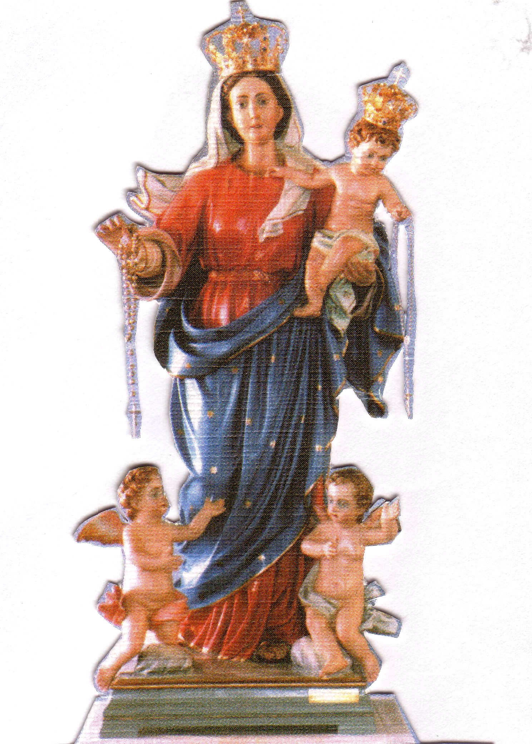
Benedizione con il S.S.. Sacramento ai malati e famiglie.
Accompagnato dal musicista Monsignor Raffaele Rossi

OUR LADY OF THE HOLY ROSARY SUNDAY 6 OCTOBER 2019
PROGRAM:
2.00pm - Prayers & Procession with the Statue of Our Lady. Mysteries of the Rosary Meditated.
3.00pm - Holy Mass concelebrated by Fr Michael Cagna & Fr Emmanuel Bonello
Musician: Rev. Raffaele Rossi
Benediction for the sick and families. The Children will be entrusted to the maternal protection of Mary.

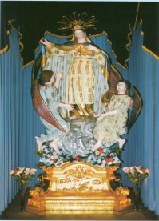
FEAST OF STELLA MARIS

FRIDAY 18 OCTOBER:
6.30pm: Confessions in English and Maltese will be heard at St. Joseph the Worker Church.
7.00pm: Mass celebrated by Rev. Fr Frank Buhagiar
There will be presentation of flowers to Our Lady.
After Mass everyone is invited to join us for some refreshments.
SATURDAY 19 OCTOBER:
6.30pm: Feast Dinner Dance will be held at Emerald Receptions. DJ Domenic will be entertaining us on the night. Later on in the night the Maltese United Brass Band will join us to entertain us playing various joyous marches.
SUNDAY 20 OCTOBER:
2.30pm: High Mass: Celebrated by Parish Priest Canon Manuel Bonello, Rev Fr Frank Buhagiar, Rev Fr Lonnie Borg assisted by Desmond Calleja. And the Stella Maris Choir. All Associations are invited to take part by joining us in the church celebrations as well as during the procession carrying their banners.
4.00pm: The procession with the beautiful Statue of Stella Maris will commence. The Maltese Own Band Philharmonic Society Inc and the MMG concert band of Vic. Will accompany the statue around the streets
of the Church.
6.00pm: After the procession everyone is welcome to come in the Hall where the two Maltese Bands will perform. Afterwards there will be DJ Domenic to entertain us.

THERE WILL BE FOOD AND DRINKS FOR SALE. EVERYONE IS WELCOME.
THE COMMITTEE WISHES EVERYONE A GOOD TIME DURING THESE FESTIVITIES.

