As we come and worship, we remember the wurundjeri people, the original custodians of this land

FIRST READING Exodus 20:1-17
The Law was given through Moses.

RESPONSORIAL PSALM SALMO RESPONSORIALE
Lord, you have the words of everlasting life. | Signore, tu hai parole di vita eterna.
SECOND READING Corinthians 1:22-25
We are preaching a crucified Christ, a scandal to many, but to those who have been called, the wisdom of God.
.

GOSPEL ACCLAMATION CANTO AL VANGELO
Praise to you, Lord Jesus Christ, king of endless glory!  God loved the world so much, he gave us his only Son, that all who believe in him might have eternal life.  Praise to you, Lord Jesus Christ, king of endless glory! | Lode e onore a te, Signore Gesu’!  Dio ha tanto amato il mondo da dare il Figlio unigenito; chiunque crede in lui ha la vita eterna.  Lode e onore a te, Signore Gesu’!
GOSPEL John 2:13-25
Destroy this sanctuary, and in three days I will raise it up..

THANKS TO THOSE WHO GAVE LAST WEEK
^{st} Collection - Thanksgiving Offering…………………………..$336.00
- Loose Money…………………………………….$315.00
2nd Collection - Presbytery………………………………………..$260.00

PLEASE NOTE THAT THOSE WHO ARE ROSTERED ON TO READ OR GIVE COMMUNION AT MASS ARE KINDLY ASKED, IF POSSIBLE, TO ARRIVE 10 MINUTES BEFORE MASS STARTS

LECTORS - THIS WEEK 03/03/2024 SPECIAL MINISTERS
5.30pm (SAT) – MALTESE MASS (Selected) MALTESE MASS (Selected)
9.00am (SUN) – L Calafiore & G Calvi F Pascuzzi, O Strangis & G Barbaro
10.30am (SUN) – J Iaria L De Marco & M Mizz
LECTORS – NEXT WEEK 10/03/2024 SPECIAL MINISTERS
5.30pm- E Saliba T Nguyen & B Nadenbousch
9.00am- C Brunetti & G Barbaro P Sparano, M Sinopoli & P Leggiero
10.30am- B Clark-Loh G Caruana & S Rottura

YOUR PRAYERS ARE REQUESTED FOR THE FOLLOWING RECENTLY DECEASED
Giuseppe FAZZARI, Romolo ROSSELLI, Charlie MIFSUD
ANNIVERSARIES & SPECIAL MEMORIES
Bishop Nicholas CAUCHI, Fr Andrew CAMILLERI, Frank (Francesco) ROCCA,
Giovanna SARDANO, Elena MARKESICH, Lucia NICASTRI,
Antonio, Maria -Concetta, Annuziata, Marie & Gregorio LOVERSO

ST JOSEPH THE WORKER
_______________________________________NORTH RESERVOIR _________________________________________

79 Wilson Boulevard, North Reservoir 3073

Parish House/Office Tel: 9460 3013 Fax: 9460 8832
Email: reservoirnorth@cam.org.au
www.stjosephtheworker.org.au
School Tel: 9469 7800 Fax: 9462 2949

SUNDAY MASS TIMES: Fr Emmanuel Bonello–Parish Priest WEEKDAY MASS TIMES:

Mb: 0431 643 674

Sat 5.30pm - English Mrs Maria Barnes – School Principal
Sun. 9.00am - Italian Mrs Liz Pistoni – Parish Secretary Tue. 10.00am Italian

Sun. 10.30am – English Wed. 9.10am - English

Thur. 9.10am - English

Maltese Mass Fri. 9.10am - English Sat. 8.30am - English
1st Saturday of the Month 5.30pm Sat. 8.30am-English
Baptisms – Sunday 12.00pm Reconciliation:
Marriages – by Appointment (Individual Confessions)
Sat. 5.00pm or by Appointment

3rd Sunday of Lent Year B 3 March, 2024
JeSUS’ DIVINE MISSION
.If there is one incident in Jesus’ life that leads us to question his judgment, the story of him taking a whip and angrily driving people out of the temple must rank as a strong contender. We have heard in recent weeks that Jesus can be forthright in challenging people – even calling pharisees ‘hypocrites’ to their faces! But our major image is of a patient and forgiving Jesus rather than someone striking out at people with a raging temper. So, how are we to understand this story? A good place to start is another story of Jesus visiting the Jerusalem temple with his mother and father when he was a twelve-year old boy. On that occasion, Jesus becomes so caught up by the temple experience he misses the caravan taking his family back to Nazareth. When his parents realise Jesus is missing, they hasten back to find him among the temple priests and elders, engaging with them about the meaning of the Scriptures. Now, the temple for traditional Israelites was the holiest of all places on earth enabling people to experience the presence of the living God in their lives in an unsurpassed way. This must have been Jesus’ boyhood experience evident in his response to his confused parents: “Why were you searching for me? Did you not know I must be in my Father’s house?” So, when Jesus returns to the temple some twenty years later and finds it filled with hawkers, merchants and other traders, he is incensed that greed and money-lust have turned his “Father’s house” into a marketplace. However, rather than directing his anger to the little people who are simply trying to make a living in a hostile world, surely Jesus should have confronted the temple priests who allowed – no doubt benefited financially from – this defilement of God’s house. Jesus has this opportunity to respond to the chief priests when they challenge him for his table-turning, whip-lashing behaviour. In answer to their question – “On what authority do you do this?” – Jesus’ strange response confounds everyone: “Destroy this temple and I will raise it up again in three days”. Somehow, this is a moment of insight for Jesus. He begins to realise his mission of communicating God’s love and forgiveness will result in the destruction of the other temple – his own body – on a Cross. Yet, God’s glory will always shine through beyond suffering, cruelty and death itself. This is the paradox St Paul writes about in his letter to the Corinthians. He realises how preaching a crucified Christ is folly to Jews and Greeks alike. Yet Pau knows we must acknowledge our own sinfulness and stupidity if we are to experience God’s power and wisdom.
Too often, we are like the temple traders busy with our own pursuits rather than seekers of the living God. We often ignore God’s covenant because we are afraid to witness to a crucified-and-risen Christ who heals our weakness and failures with divine love and mercy.
Gerard Hall SM

PROJECT COMPASSION
THIRD SUNDAY OF LENT CARITAS AUSTRALIA

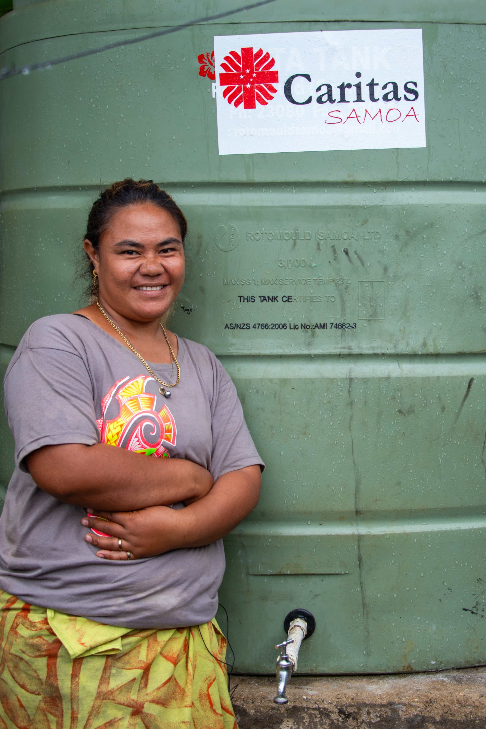
Samoa may be a country surrounded by water, but access to clean drinking water is scarce in some areas, with many families facing extreme hardship as a result. Leaia lives with her five children, husband, brother and sister-in-law on the island of Upolu in Samoa. Not having access to a reliable source of clean water caused Leaia a lot of worry. Their home is not connected to a piped water system, so they had to rely solely on rainwater collected in old fridges. When their water ran out, Leaia had to walk with her young children to collect water in buckets and containers from a neighbour down the street. With the support of Caritas Australia's local partner, Caritas Samoa, a water tank was installed at Leaia's home. She and her family now have a steady supply of clean drinking water at home. Next year, they will also have a toilet built, with the support of Caritas Samoa, which will further improve their health and living conditions. “We are very thankful and grateful for the water tank. It has helped us so much and made our daily life easier,” Leaia said. Please donate to Project Compassion.
Together, we can help vulnerable communities face their challenges today and build a better tomorrow for all future generations. You can donate through Project Compassion donation boxes and envelopes available from your parish, by visiting caritas.org.au/project-compassion or by calling 1800 024 413.

YEAR OF PRAYER – LENT – OUR FATHER

In his latest reflection Archbishop Peter A. Comensoli said that “Lent is indeed a journey back to the merciful Father, to experience his embrace. Jesus taught us this when he taught us how to pray. The Lord’s Prayer, as we know it, is both a personal and a communal prayer. It is to God and with others.” This Lenten reflection of Archbishop Peter, follows his earlier reflections on how to enter into this Year of Prayer. Continuing on about the Lord’s Prayer, the Archbishop noted that “The Our Father does not begin with asking but rather with an acknowledgment. It shows us God and who God is for us: your name be holy, your kingdom come, your will be done. It's about our yearning for God. Then there are the petitions: give us the food we need. Forgive us as we are to forgive. Don’t put us to the test. Deliver us from the evil one. And central to all of that is the petition of forgiveness. To forgive and to be forgiven goes to the heart of the mission of Jesus, to what he came to do for us.” Here the Archbishop reminded us that Forgiveness and Reconciliation are the heart of the Gospel we proclaim. Then in conclusion he said that: “Praying our way through Lent this year, returning to God our Father, is a beautiful way in which we participate in our faith.”

VIA CRUCIS – STATIONS OF THE CROSS PRAYERS
Every Friday during Lent there will be Stations of the Cross Prayers, (English and Italian) after the 9.10am morning mass.

MEMORIAL MASS
Sunday 10 March Memorial Mass at 9.00 am for Paolo Porcu.

BAPTISMS
Congratulations to Roman & Leon Polito children of Giuseppe and Shanel, who will be baptised this weekend. We welcome them into our parish community and assure the family of our prayerful best wishes on this happy occasion.

DAY PRAYERS FROM 2024 LENT PRAYER CALENDAR ( MARCH 2 - 9)
Saturday March 2: Pray for Honesty
Sunday March 3: Pray for Self-Discipline
Monday March 4: Pray for Faithfulness
Tuesday March 5: Pray for Graciousness
Wednesday March 6: Pray for Courage
Thursday March 7: Pray for Perserverance
Friday March 8: Pray for Selflessness
Saturday March 9: Pray for Eternal Life

HAND SANITISING FOR SAFETY PRACTICES
As in many other places for people to sanitise their hands, please know that “Hand Sanitiser Bottles” a re available in the Church, at the entrance and side doors and at the seats on the way to receiving communion. When you go to receive communion, please sanitise your hands and receive communion Only on the Hand. Please feel free, if you wish to wear a mask. THANKS.

MASS ON C31 (d.44)
For those unable to attend church due to illness or other reasons there is an opportunity to follow the 11.00am Sunday Mass from St. Patrick’s Cathedral, Melbourne, which is broadcast live on the TV station C31 Melbourne, which is channel 44 on digital TV.

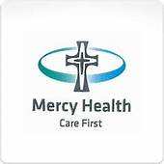
MERCY HEALTH CARE FIRST
At Mercy Place Keon Park, caring for you is our top priority.
Our qualified and compassionate aged care teams tailor care according to your personal interests and needs, providing you with comfort and assurance. Our goal is simple: to enable you to have the best day possible, each and every day. Call us now on 1300 372 616 to book a tour. We look forward to welcoming you into your new home.
Mercy Place Keon Park, 15 Tunaley Parade, Keon Park, Vic 3073 | mercyhealth.com.au


MISSION: TRASFORM LIVES:-THEIRS AND YOURS.
Communities in Africa, Asia, Australia and the Pacific are looking for qualified and experienced Australians from ALL sectors to share their skills with those who have had little opportunity for formal training. You too will learn and grow within a most welcoming community. Experience the joy as you assist to change lives. Learn more: Join our Mission Webinar March 5 th, 2024, 6:00 - 6:30 pm. 63 years preparing Australians for enduring global relationships to build sustainable, self-reliant, community development. Learn Even More: Join our two-week tour to Timor-Leste on 06/05/2024 to see Palms program participants our local partner communities in action together. Contact: 02 9560 5333 palms@palms

The Parish of St Joseph the Worker, North Reservoir and the Diocese of Melbourne are committed to the care, wellbeing and protection of children, young people and vulnerable people in our community.

