As we come and worship, we remember the wurundjeri people, the original custodians of this land

FIRST READING Genesis 12:1-4
The call of Abraham, the father of God’s people.

RESPONSORIAL PSALM SALMO RESPONSORIALE
Lord let your mercy be on us, as we place our trust in you. | Donaci, Signore, il tuo amore: in te speriamo.
SECOND READING 2 Timothy 1:8-10
God has saved us, and called us to be holy.

GOSPEL ACCLAMATION CANTO AL VANGELO
Glory and praise to you, Lord Jesus Christ!  From the shining cloud the Father’s voice is heard: this is my beloved Son, hear him.  Glory and praise to you, Lord Jesus Christ! | Lode e onore a te, Signore Gesu’!  Dalla nube luminosa, si udi la voce del Padre: Questi e’ il mio Figlio, l’amato ascoltatelo.  Lode e onore, a te, Signore Gesu’!
GOSPEL Matthew 17:1-9
His face shone like the son.

THANKS TO THOSE WHO GAVE LAST WEEK
^{st} Collection - Thanksgiving Offering…………………………..$514.00
- Loose Money…………………………………….$287.00
2nd Collection - Presbytery………………………………………..$201.00

PLEASE NOTE THAT THOSE WHO ARE ROSTERED ON TO READ OR GIVE COMMUNION AT MASS ARE KINDLY ASKED, IF POSSIBLE, TO ARRIVE 10 MINUTES BEFORE MASS STARTS

LECTORS - THIS WEEK 05/03/2023 SPECIAL MINISTERS
5.30pm (SAT) – MALTESE MASS (Selected) MALTESE MASS (Selected)
9.00am (SUN) – C Agostinelli & F Multari D Biasibetti, G Calvi & P Leggiero
10.30am (SUN) – N Sua T Nguyen & M Mizzi
LECTORS – NEXT WEEK 12/03/2023 SPECIAL MINISTERS
5.30pm- B Nadenbousch T Nguyen & N Ziino
9.00am- R DiGulielmo & R Pino L Cavedon, A Sonza & N Mercuri
10.30am- B Clark-Loh D Nguyen & J Iaria
YOUR PRAYERS ARE REQUESTED FOR THE FOLLOWING RECENTLY DECEASED
Joseph SULTANA
ANNIVERSARIES & SPECIAL MEMORIES
George AGIUS, Bishop Nicholas CAUCHI, Fr Andrew CAMILLERI,
Agata & Francesco DE RANGO, Famiglia MONARCA, Corrado PELLIGRA,
Giovanni LIUCCI, Pasquale CAMORATO, Giovanna MASCARA,

ST JOSEPH THE WORKER
_______________________________________NORTH RESERVOIR _________________________________________

79 Wilson Boulevard, North Reservoir 3073

Parish House/Office Tel: 9460 3013 Fax: 9460 8832
Email: Parish@stjosephtheworker.org.au
www.stjosephtheworker.org.au
School Tel: 9469 7800 Fax: 9462 2949

SUNDAY MASS TIMES: Fr Emmanuel Bonello–Parish Priest WEEKDAY MASS TIMES:

Mb: 0431 643 674

Sat 5.30pm - English Mrs Maria Barnes – School Principal
Sun. 9.00am - Italian Mrs Liz Pistoni – Parish Secretary Tue. 10.00am Italian

Sun. 10.30am – English Wed. 9.10am - English

Thur. 9.10am - English

Maltese Mass Fri. 9.10am - English Sat. 8.30am - English
1st Saturday of the Month 5.30pm Sat. 8.30am-English
Baptisms – Sunday 12.00pm Reconciliation:
Marriages – by Appointment (Individual Confessions)
Sat. 5.00pm or by Appointment

2nd Sunday of Lent Year A 5 March, 2023
Mountain top experience

In just a few weeks’ time we will hear the shocking accounts of Jesus’ arrest, his torture, his passion and his death on a cross. But today, early in our Lenten journey, we recall one of the moments in his life when his divine identity is revealed to his closest disciples.

There, up a high mountain, before Peter, James and John, Jesus was transfigured. His face shone like the sun and his clothes became white as light. Moses and Elijah also appeared, conversing with Jesus.
What an amazing sight for those three disciples: Jesus in his dazzling glory. It is a moment of sheer ecstasy. No wonder they wanted to stay in that moment forever. Peter exclaims: “Lord, it is good that we are here.” Wanting to stay there, he suggests building three tents, one each for Jesus, Moses and Elijah. But a voice from heaven speaks, as at Jesus’ baptism at the start of his public ministry: “This is my beloved Son, with whom I am well pleased; listen to him.”
It is a gentle but firm correction for Peter! There was to be no staying there; rather there is a mission to accomplish. Listen to him! Jesus, his identity as Son of God now so clearly revealed to them, is destined to suffer and die. How Peter struggled to listen and to hear that the Messiah would suffer. The Church always recounts this story of the transfiguration on the second Sunday of Lent. This year we hear Matthew’s account. As for the disciples, the transfiguration reminds us of who Jesus really is. He is the Son of God, truly and fully divine. He is God with us. We are to remember this when he is tortured and crucified, all for our sake and for our salvation.
We too will have the occasional mountain-top experiences in our lives, those precious moments when we are our very best selves and life is blissful.
However, just as surely, suffering and hardship will also come our way, as it did for Jesus. But the message that resounds through the gospels, and especially in the Easter liturgies, is that God works in and through suffering. Suffering is no aberration or obstacle on our journey to the fullness of life and to the glory that is promised to us. So it was for Jesus. His resurrection is not just as a moment of triumph “after” his suffering and quite separate from it, but a mystery born in and of his suffering. So too for us. So let us live each day in faith, hope and love, with courage and trust that God does not desert us, but is truly and steadfastly with us, through hard times and good. As The Letter to Timothy reminds us today: “Bear your share of hardship for the gospel with the strength that comes from God.”
Anne Hunt


Project Compassion Sunday
4 & 5 March



Tereesa is a Gamilaroi woman from Western Sydney who struggled with homelessness while raising her four children. Through the Baabayn Young Mums and Bubs Group, Tereesa was able to reconnect with her culture and create a better future for her children

Please donate to Project Compassion 2023

Together, we can help vulnerable communities face their challenges today and build a better tomorrow For All Future Generations.

You can donate through Project Compassion donation boxes and envelopes available from your parish, by visiting caritas.org.au/project-compassion, or
by calling 1800 024 413.

SECOND SUNDAY OF LENT YEAR A JESUS ON THE MOUNTAIN
In his message of Lent 2023 Pope Francis said: “The Lenten journey of penance and the journey of the Synod alike have as their goal a transfiguration, both personal and ecclesial. A transformation that, in both cases, has its model in the Transfiguration of Jesus and is achieved by the grace of his paschal mystery. So that this transfiguration may become a reality in us this year, I would like to propose two “paths” to follow in order to ascend the mountain together with Jesus and, with him, to attain the goal.” Pope Francis refers to God’s invitation as the voice from the cloud saying to the three disciples: “This is my Son the Beloved, … Listen to Him”. So, as the Pope says, “we need to listen to Jesus … First, in the Word of God which the Church offers us in the Liturgy. … Second, we listen to Jesus through our brothers and sisters especially in the faces and stories of those who are in need.” – Full message on: https://press.vatican.va/.../pubb.../2023/02/17/230217c.html

BAPTISMS
Congratulations to Sian Pieri child of James and Pamela, and Giada Chillico child of Riccardo and Stefania who will be baptised this weekend. We welcome them into our parish community and assure the families of our prayerful best wishes on this happy occasion.

VIA CRUCIS – STATIONS OF THE CROSS PRAYERS
Every Friday during Lent there will be Stations of the Cross Prayers, (English and Italian) after the morning mass.

CATHOLIC THEOLOGICAL COLLEGE SOLEMN CELEBRATION
Please join Catholic Theological College to celebrate 50 years of theological education at the
SUNG CELEBRATION OF EVENING PRAYER
Guest Speaker: Dr Graeme Blackman AO Chancellor of University of Divinity
Date: Sunday 5th March 2023 at 3.30pm; Location: St Patrick’s Cathedral, East Melbourne
Enq: sarah.styring@ctc.edu.au or Ph 9412 333

MISSION: CHANGE THEIR LIVES ... AND YOURS.
Communities in Africa, Asia or the Pacific are seeking Australians from a variety of professions and trades to share their skills with those who have less opportunity to develop their talents. · You will re-ignite your professional passion as you share skills with colleagues abroad; · You will strengthen individuals and organisational processes and procedures so that generations of people will have opportunities for growth long after you return home. · You will Learn. It is a life changing opportunity to work with and live amongst some of the most appreciative and resilient people you will ever meet. · You will be Supported. Since 1961, Palms Australia has supported qualified and experienced Catholics motivated to undertake this Mission. Please enquire further about potential assignments for you or someone you know: RING: 02 9560 533 or 0422 472 567. WEB: www.palms.org.au. On our website you can also see news including stories from those currently supported in Timor-Leste, Samoa, American Samoa and Thailand.

MASS ON C31 (d.44)
For those unable to attend church due to illness or other reasons there is an opportunity to follow the 11.00am Sunday Mass from St. Patrick’s Cathedral, Melbourne, which is broadcast live on the TV station C31 Melbourne, which is channel 44 on digital TV.

COVID SAFE PRACTICES
- As we come in Church, we are asked to be aware of some good practice against the
transmission of the Corona-virus.
- Please sanitise your hands as you enter the church and on the way before receiving Communion as well as on the way out of the Church. Hand Sanitiser Bottles are available at the entrances of the Church and at a seat as you walk to receive communion. Please receive Communion only on the Hand.
- Masks are not compulsory but recommended. You may wish to wear it or not. Ministers of Communion should wear a mask while distributing communion.
- THANKS to all those who have been and continue to be of great help to keep following well the required measures of Covid-19.

CONTINUING APPEALS:
CARITAS AUSTRALIA – UKRAINE EMERGENCY APPEAL
Online: https://www.caritas.org.au/donate/emergency-appeals/ukraine/ Phone: 1800 024 413

SYRIAN EARTHQUAQE APPEAL (BISHOP ROBERT RABBAT Melkite Catholic)
Contributions can be made by donating to:
MCF DGR Account Ref: Syrian Appeal BSB 062784 Account: 100011493
Donations are tax deductible and for a receipt please email : mcf@melkite.org.au or contact 02 9750 5514 for more information. Let us pray for all who are impacted by the devastating earthquake, as well as for the volunteers and emergency workers assisting them in their needs at this challenging time.
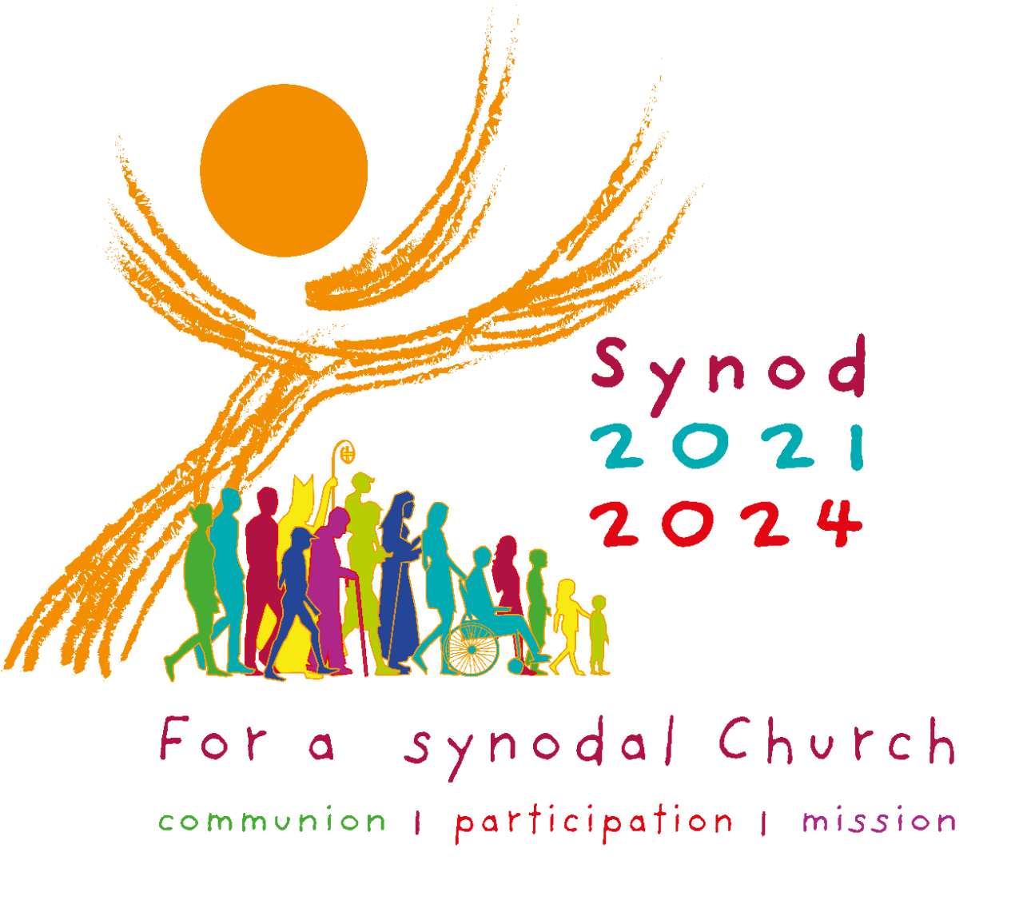
FOR A SYNODAL CHURCH: COMMUNION, PARTICIPATION AND MISSION
PRAYER FOR THE SYNOD: Adsumus Sancte Spiritus
We stand before You, Holy Spirit, as we gather together in Your name. With You alone to guide us, make Yourself at home in our hearts; Teach us the way we must go and how we are to pursue it. We are weak and sinful; do not let us promote disorder. Do not let ignorance lead us down the wrong path nor partiality influence our actions. Let us find in You our unity so that we may journey together to eternal life and not stray from the way of truth and what is right. All this we ask of You, who are at work in every place and time, in the communion of the Father and the Son, forever and ever. Amen. For general information visit: www.synod.va

The Parish of St Joseph the Worker, North Reservoir and the Diocese of Melbourne are committed to the care, wellbeing and protection of children, young people and vulnerable people in our communit

